**Creation Of AWS account and EC2 Instance:**

1. To create an AWS account. Open the AWS URL : <https://aws.amazon.com/>

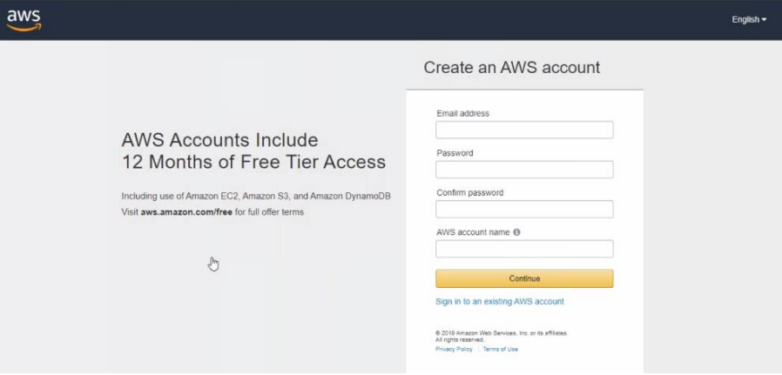

1. In step 2 fill the basic contact information and provide the information needed.

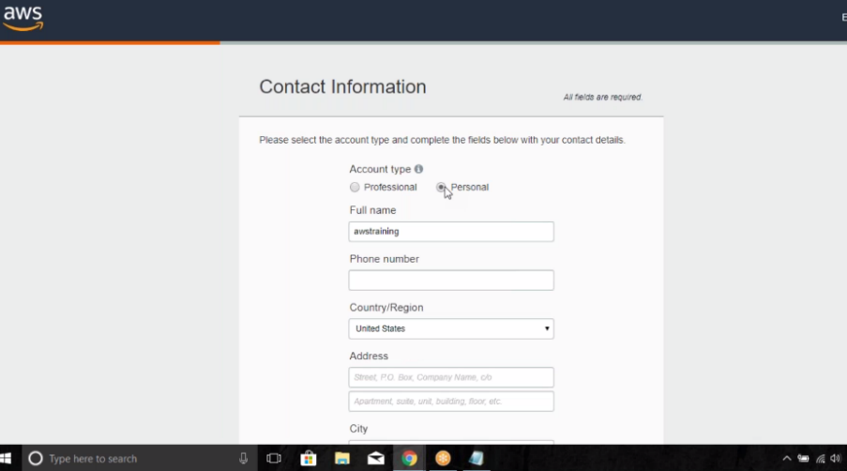

1. In Step 3 provide the credit/debit card details. In debit card, the international transaction should be on and if not, contact with customer care and have that enabled.

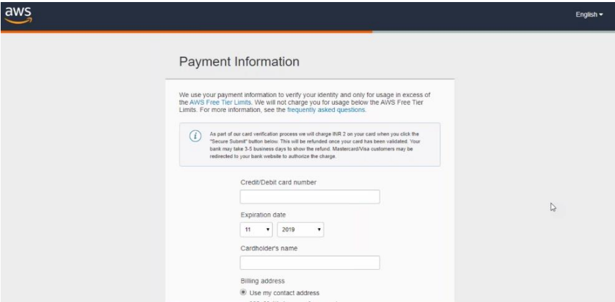

1. After this in step 4 Verify the payment details where a 2 rupee is debited and then again credited back into your account.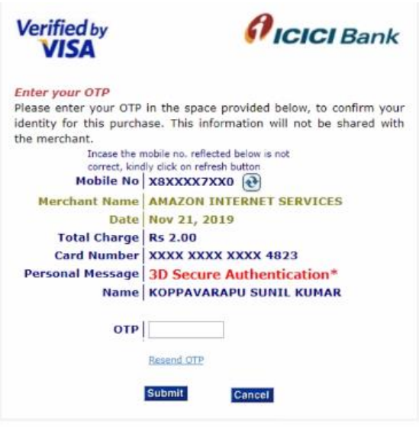
2. In the final step i.e., in step 5 select the support plan we support the basic plan.

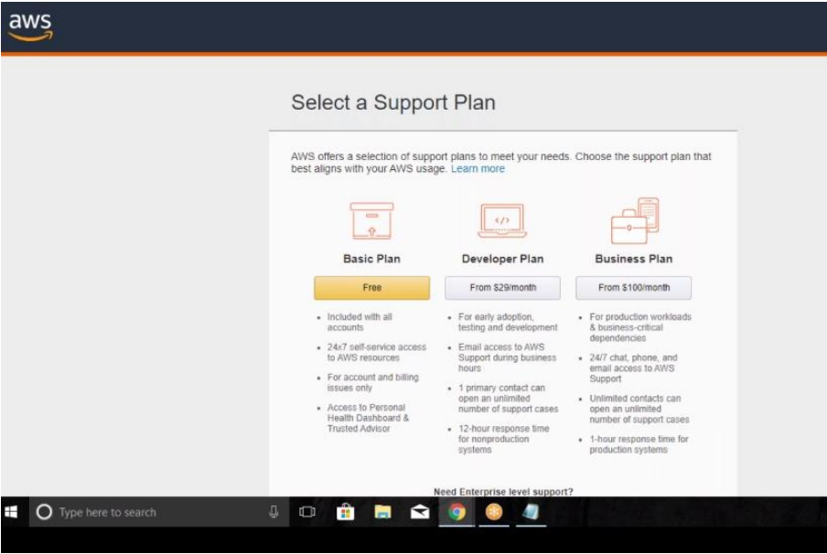

1. Now enter the role and the interest and then the aws account is created.

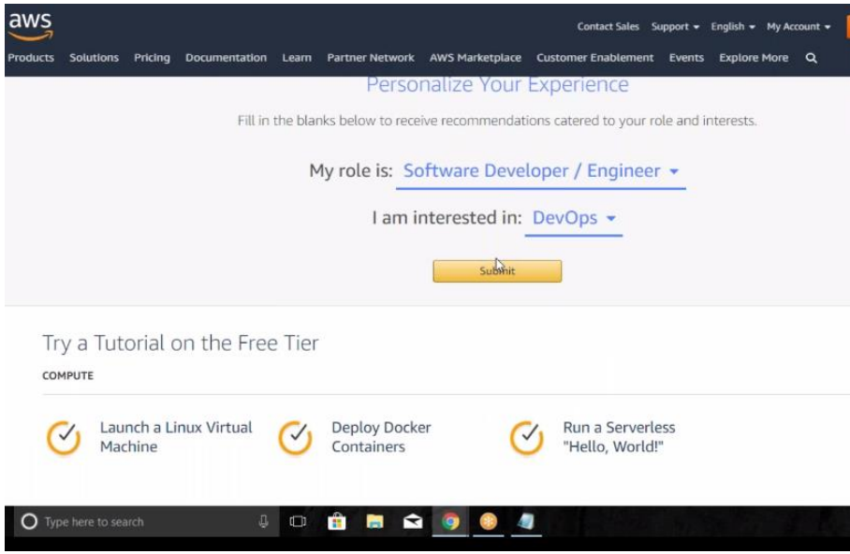

1. Login to AWS Account.

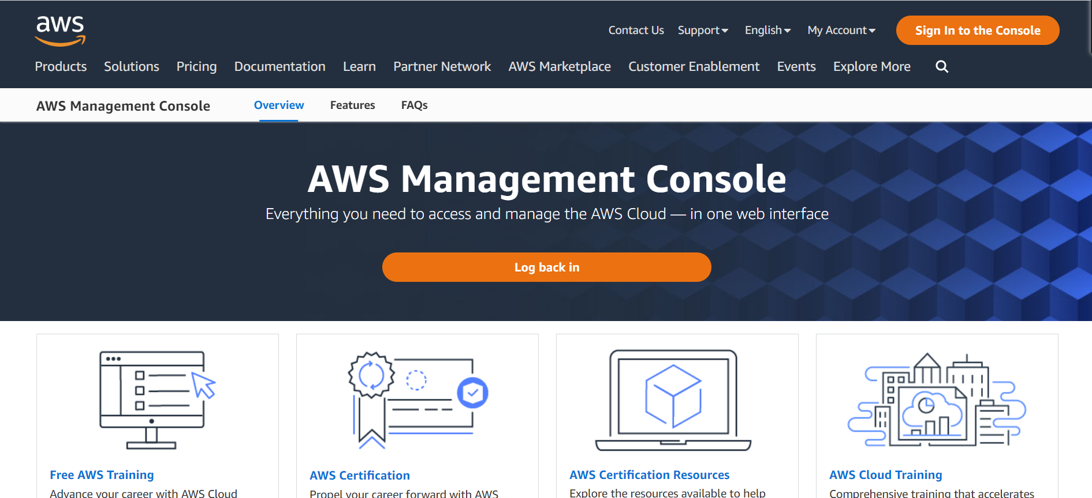

1. After the login, here we can observe that the region where we are creating this is the region of Mumbai. This region is on the top right corner of the page. In search, we need to find the EC2 Instance and click on EC2 instance.

Dashboard:

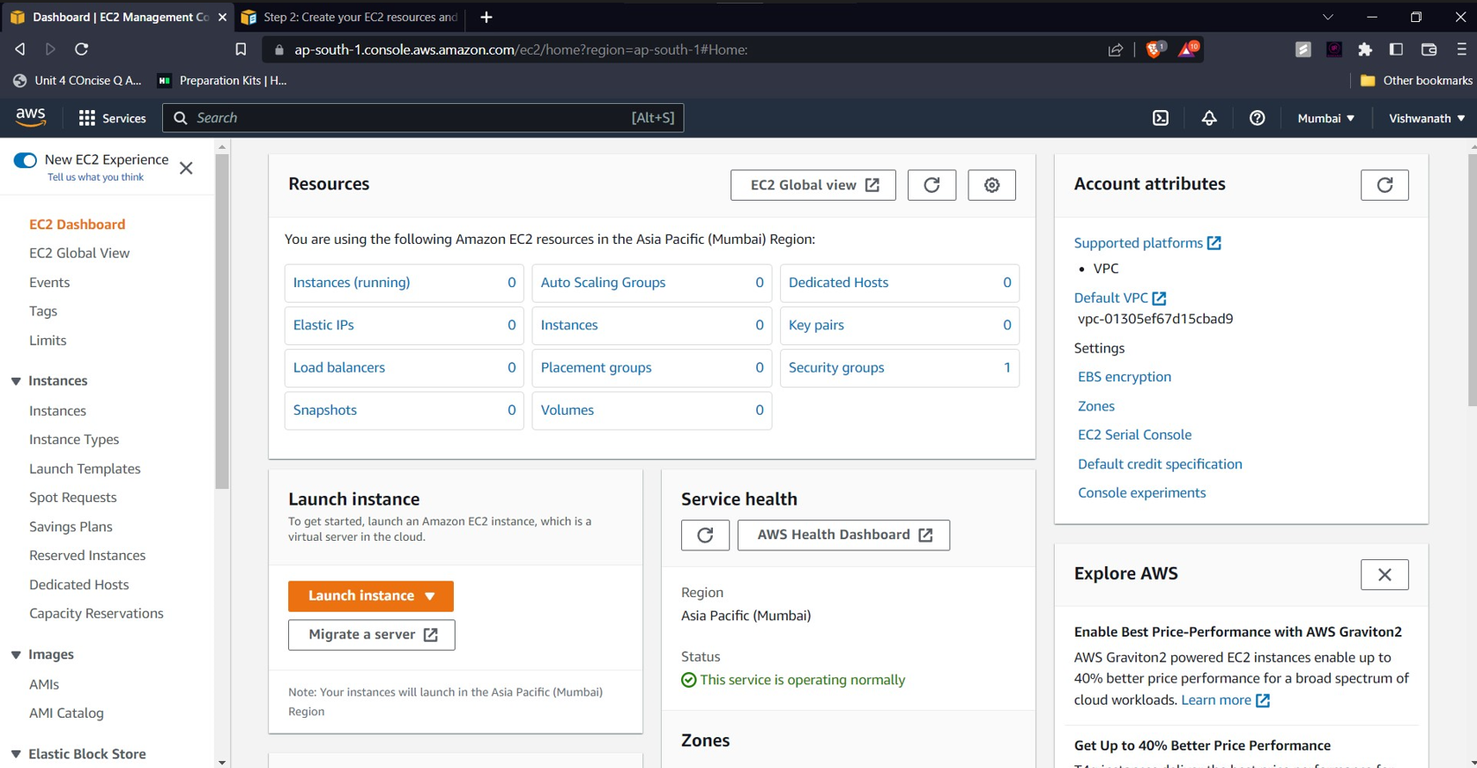

1. Click on launch instance.

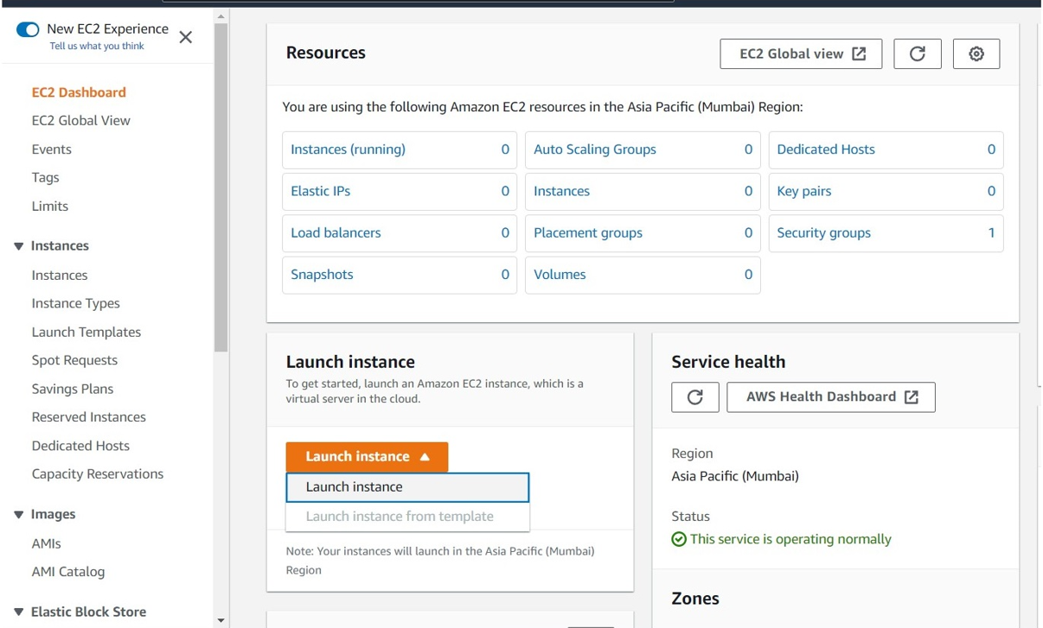

1. Here, firstly give the name of the web instance. In the Applications and OS images, select the OS image we required. Here we selecting the Ubuntu OS image and also the required free tier present ubuntu version configuration.

Here we get the description of the os we selected.

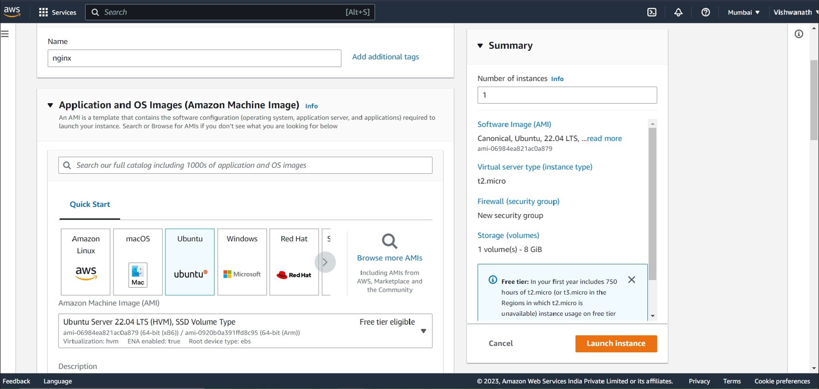

1. Select the instance type. Here, we are selecting the t2.micro which is a free tier instance.

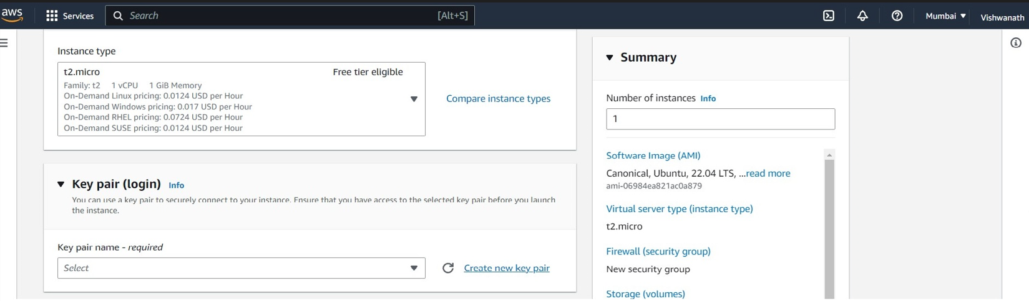

1. Select the key-pair login to securely connect to the instance.

Here , we need to provide a name to the key pair, then select the type of the key pair as pem key and download it in your system.

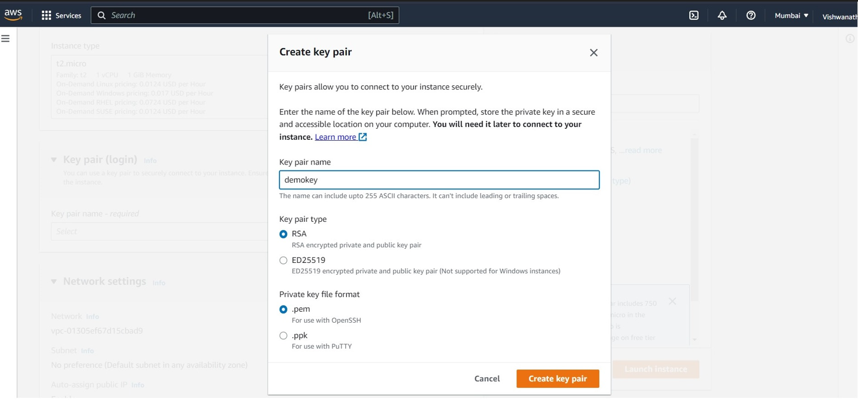

1. Next comes the firewall security groups , this will create the group with rules. Here click the check boxes i.e., allow SSH traffic , allow HTTPS traffic , allow HTTP traffic.

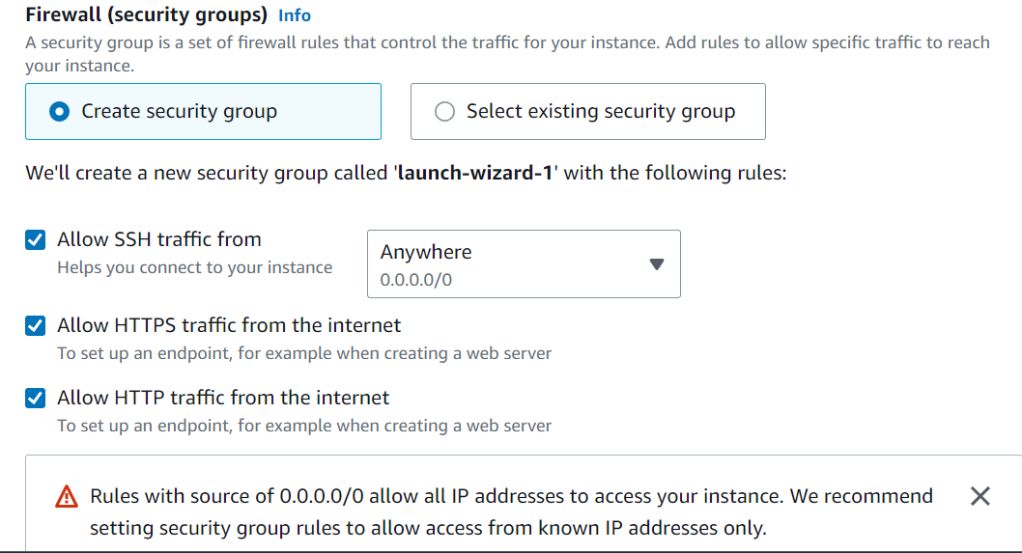

1. 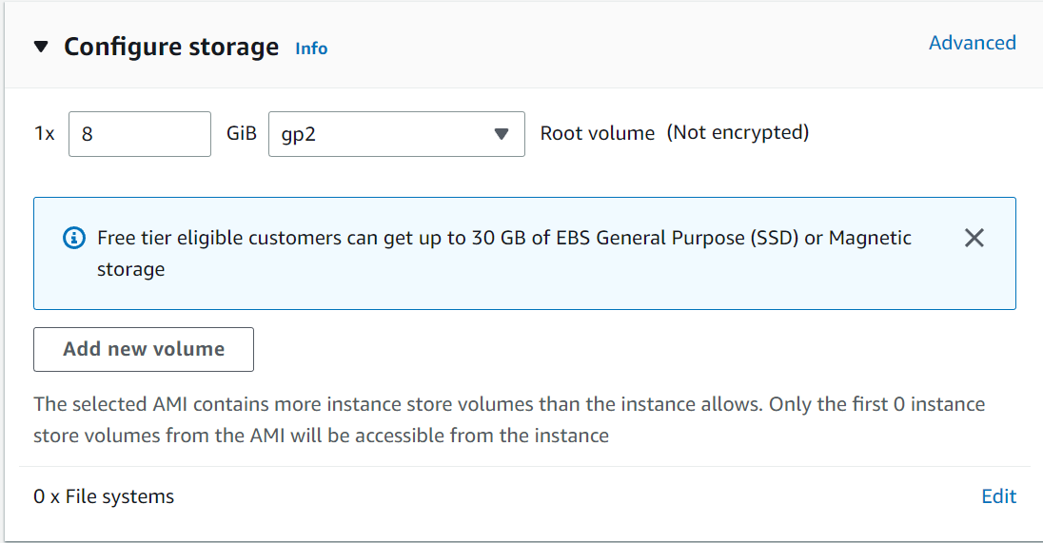Select the configure storage as 1 X 8 gb.
2. Click on launch instance.

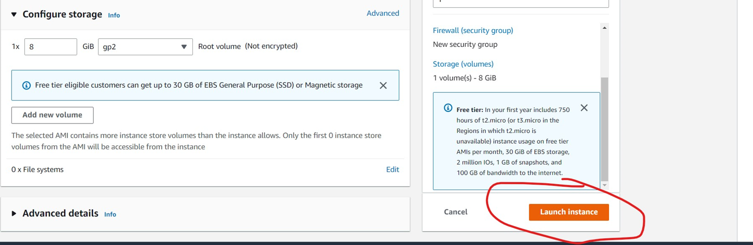

1. Here it will take some time to load and a message is displayed as follows.

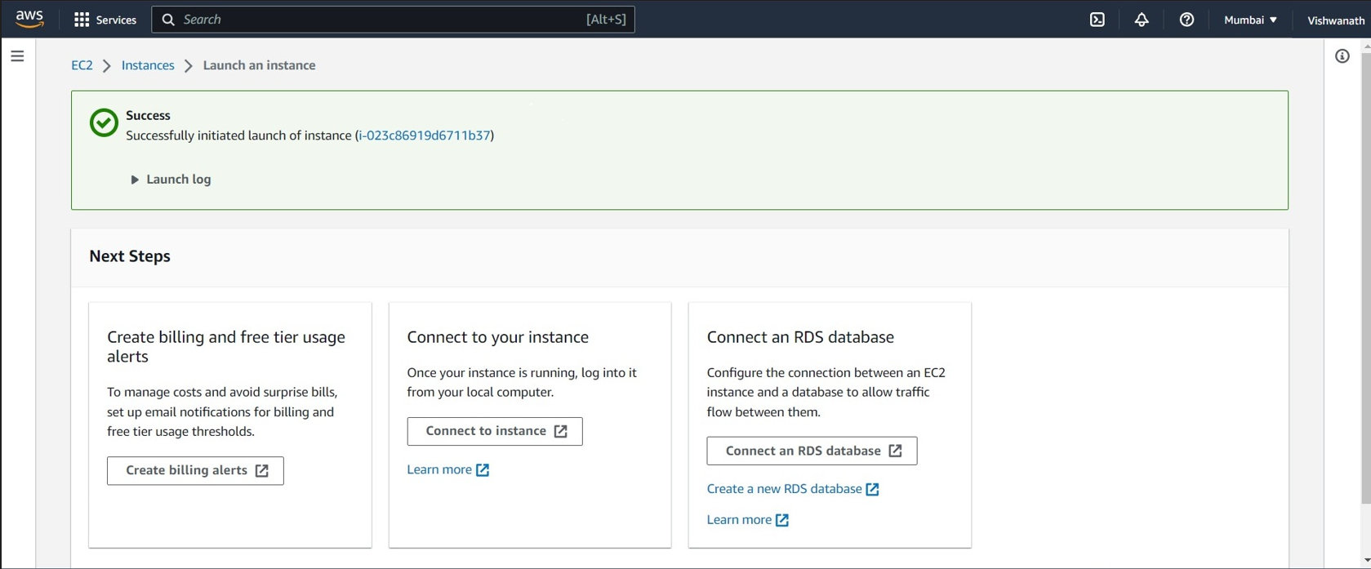

1. When we click on instances, our created Ubuntu instance can be seen in the instances list. It will take some time for 2/2 checks. The instance is created accordingly.

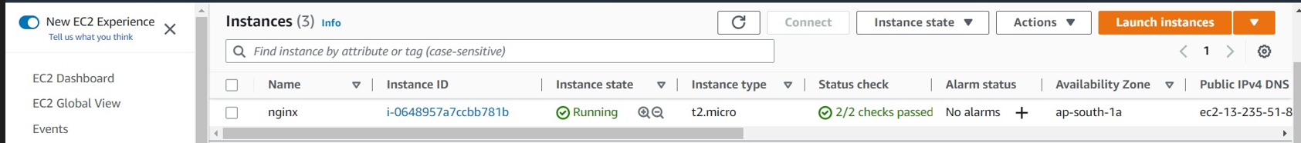

1. Click on connect to establish a connection of the instance. After clicking on connect u can see the following page.

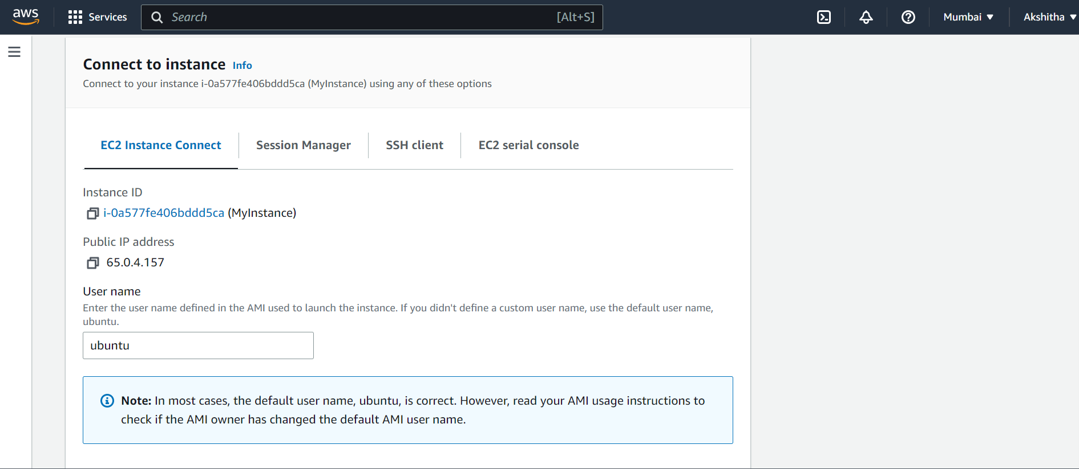

1. Here if you click on connect, a connection is established and a terminal is opened in the web browser.

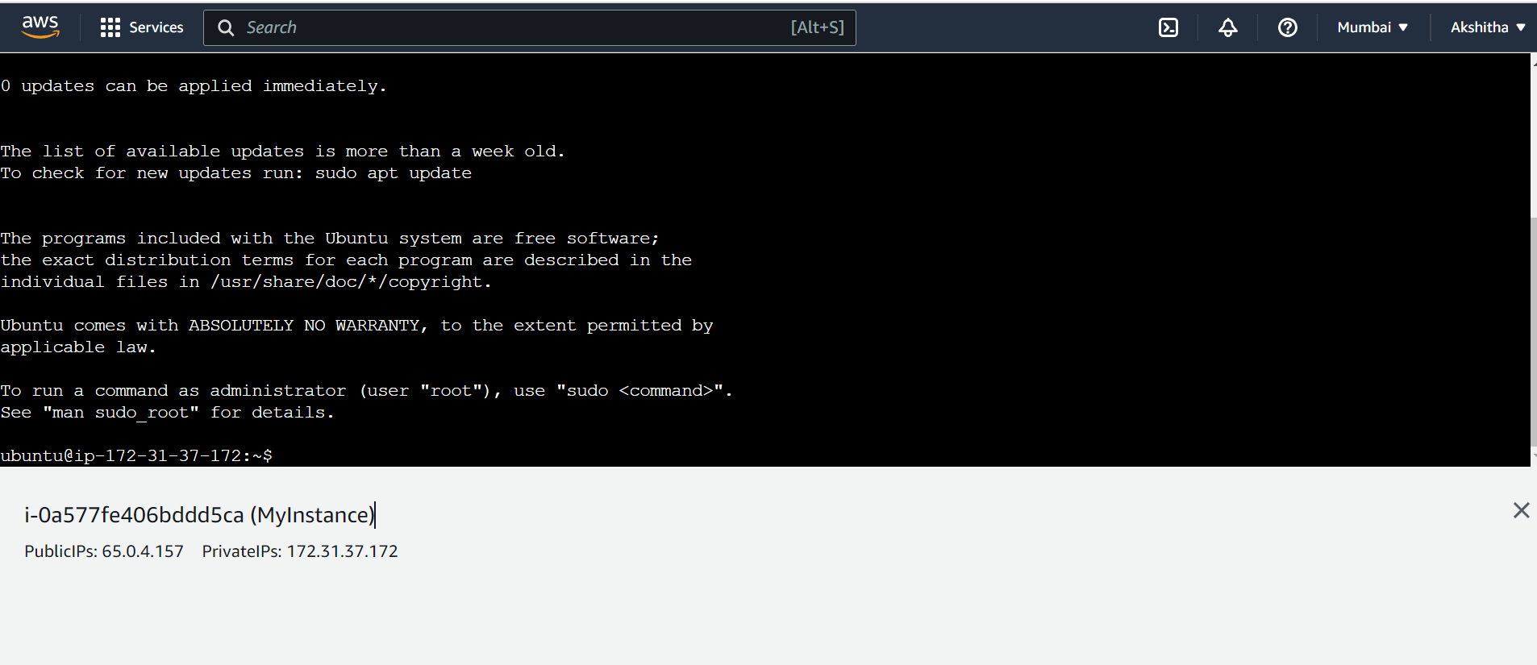

1. Terminate the session to avoid the billing charges.

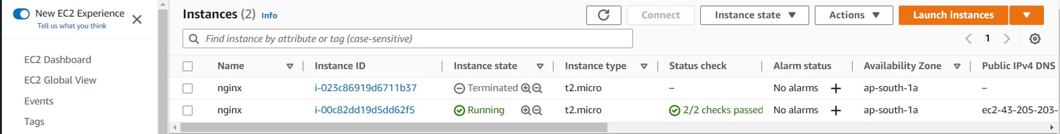

**EC2 Instance With SSH Client**

1. Login to AWS Account.



1. After the login, here we can observe that the region where we are creating this is the region of Mumbai. This region is on the top right corner of the page. In search, we need to find the EC2 Instance and click on EC2 instance.

Dashboard:



1. Click on launch instance.



1. Here, firstly give the name of the web instance. In the Applications and OS images, select the OS image we required. Here we selecting the Ubuntu OS image and also the required free tier present ubuntu version configuration.

Here we get the description of the os we selected.



1. Select the instance type. Here, we are selecting the t2.micro which is a free tier instance.



1. Select the key-pair login to securely connect to the instance.

Here , we need to provide a name to the key pair, then select the type of the key pair as pem key and download it in your system.



1. Next comes the firewall security groups , this will create the group with rules. Here click the check boxes i.e., allow SSH traffic , allow HTTPS traffic , allow HTTP traffic.



1. Select the configure storage as 1 X 8 gb.
2. Click on launch instance.



1. Here it will take some time to load and a message is displayed as follows.



1. When we click on instances, our created Ubuntu instance can be seen in the instances list. It will take some time for 2/2 checks. The instance is created accordingly.



1. Now, the instance is created successfully. Now click on connect, to SSH Client. Copy the command and powershell and change the path to pem key path and then paste the same in your powershell.

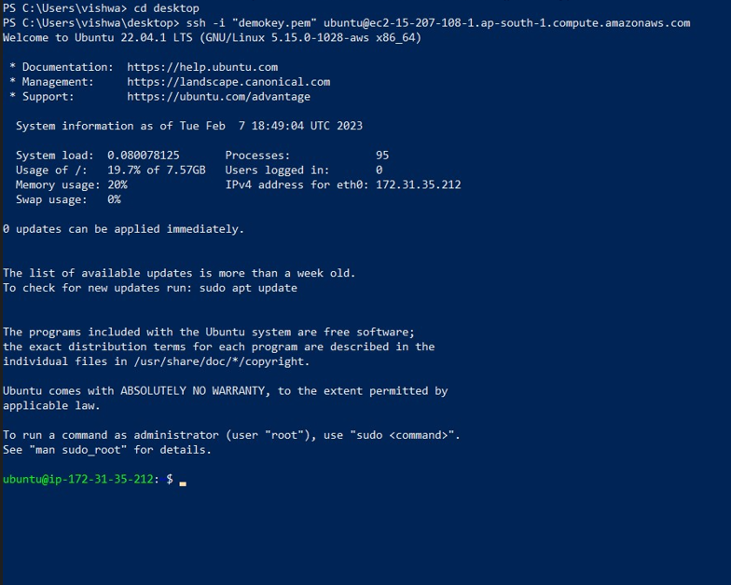

1. It will take some time to establish and the ubuntu server is available.



1. Here type the following commands to install the nginx with an public IP as DNS.

sudo apt update

sudo apt install nginx

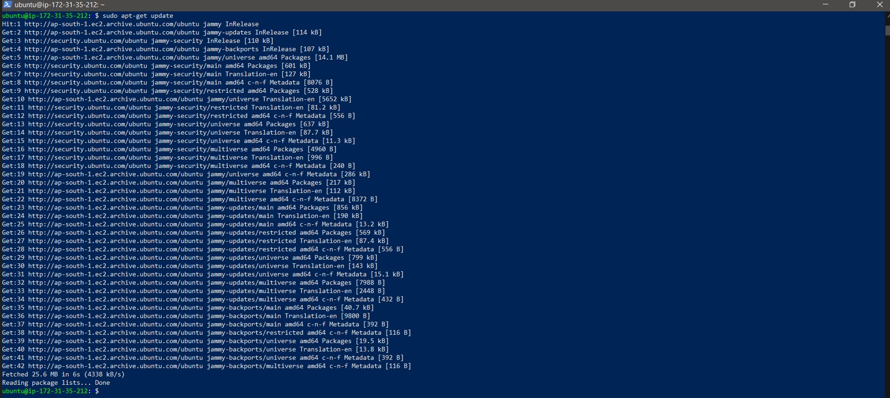

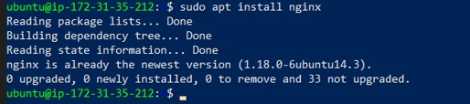

1. Copy the public key and paste it in the URL, the nginx page is displayed.

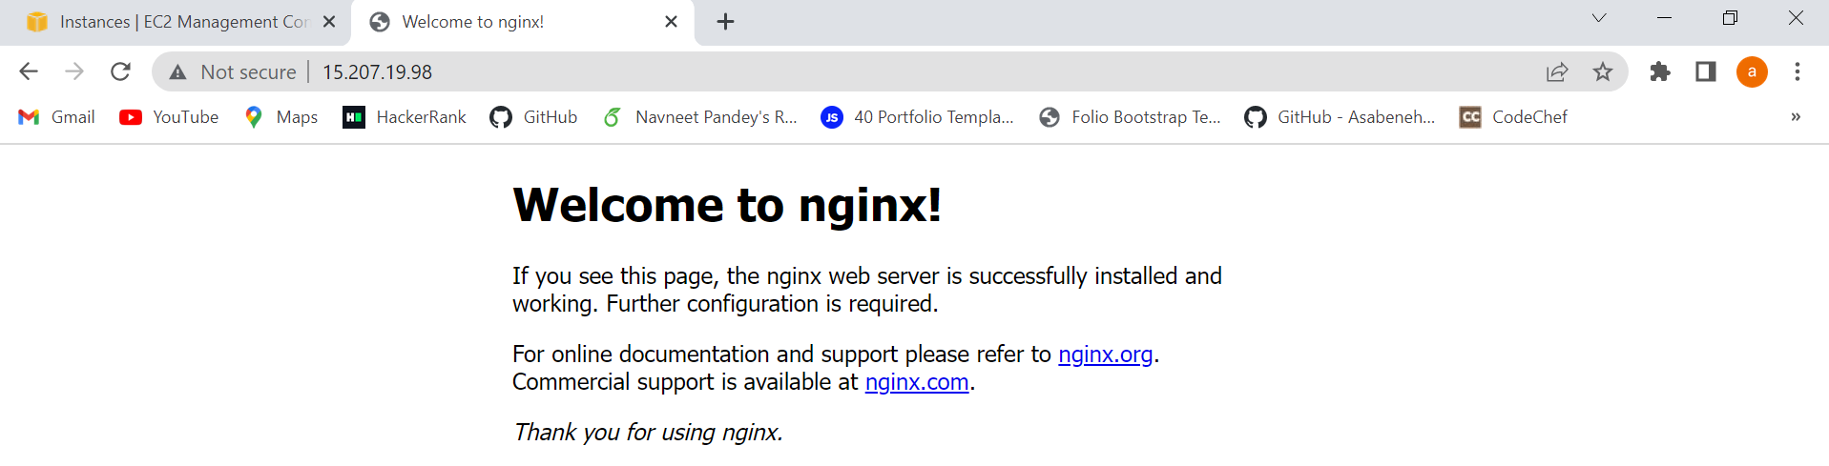

**Creation of EC2 instance with SSH (Trouble Shooting)**

1. Login in AWS account. And also Create an EC2 instance.

But donot allow the HTTP and HTTPs in the firewall security groups.

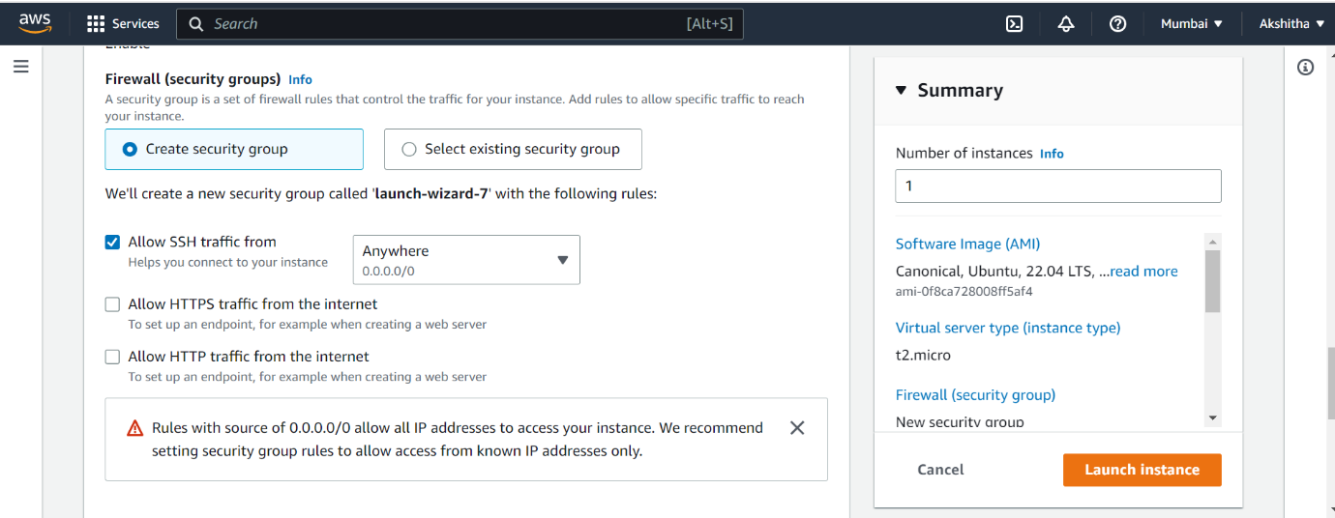

1. As we have not allowed the HTTP and HTTPs traffic the website is not opened and we see an error as follows.

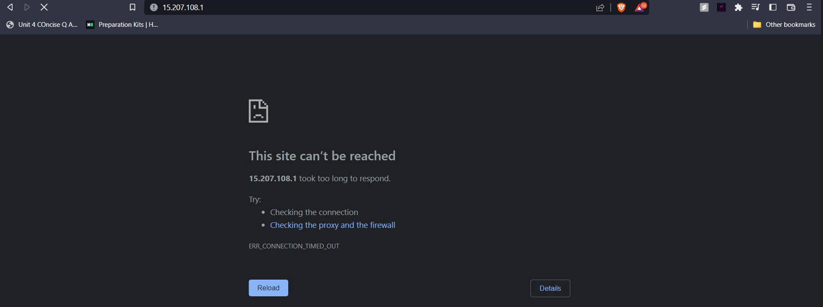

1. To trouble shoot this error we have to change the settings of the security groups.

The changes are as follows.

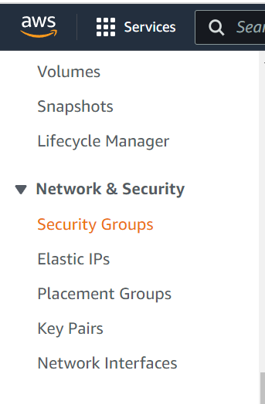Firstly, select the security groups which are on the left side of the page.

1. 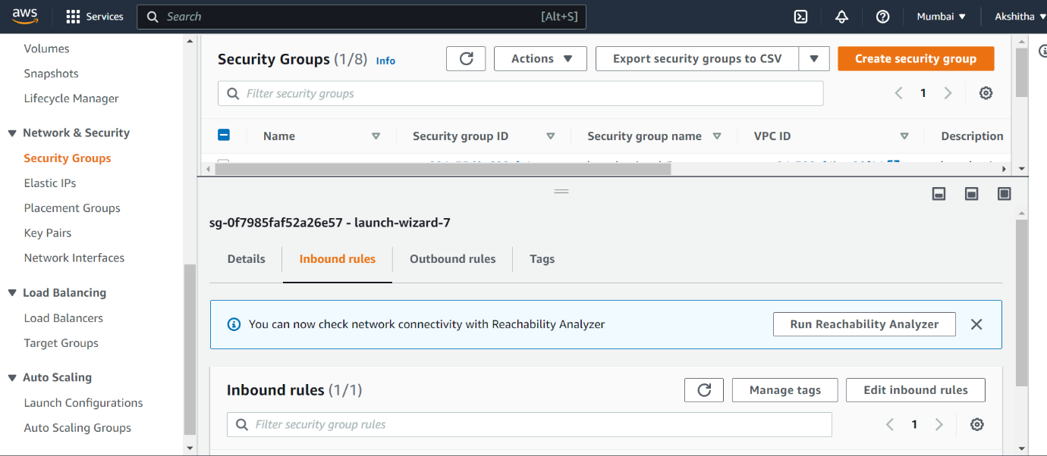Click on the security groups. In this select our instance and go to inbound rules.
2. Click on edit inbound rules.
3. 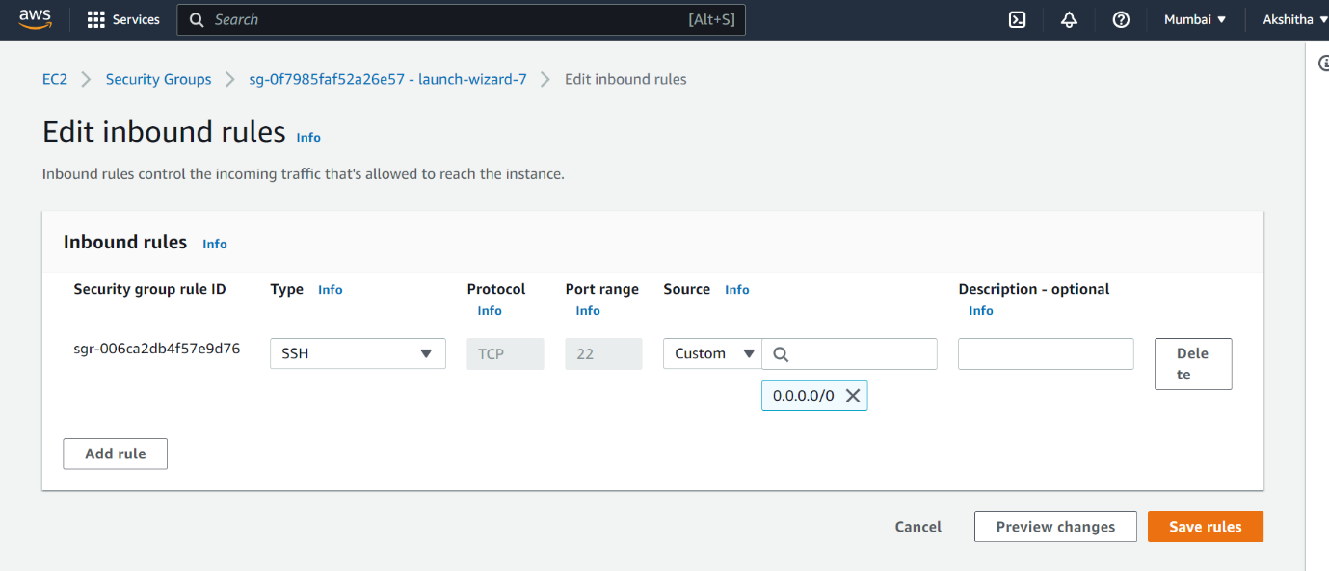Now Add rule. And add all traffic or the required traffic needs to be allowed.

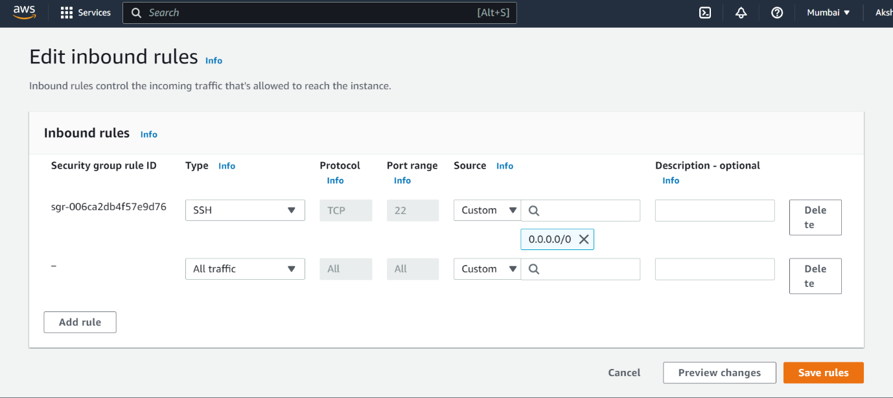

1. 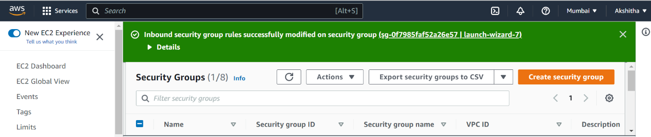Click on save changes. The changes are set. A message is displayed.
2. Now refresh the web page. The web page will be displayed.



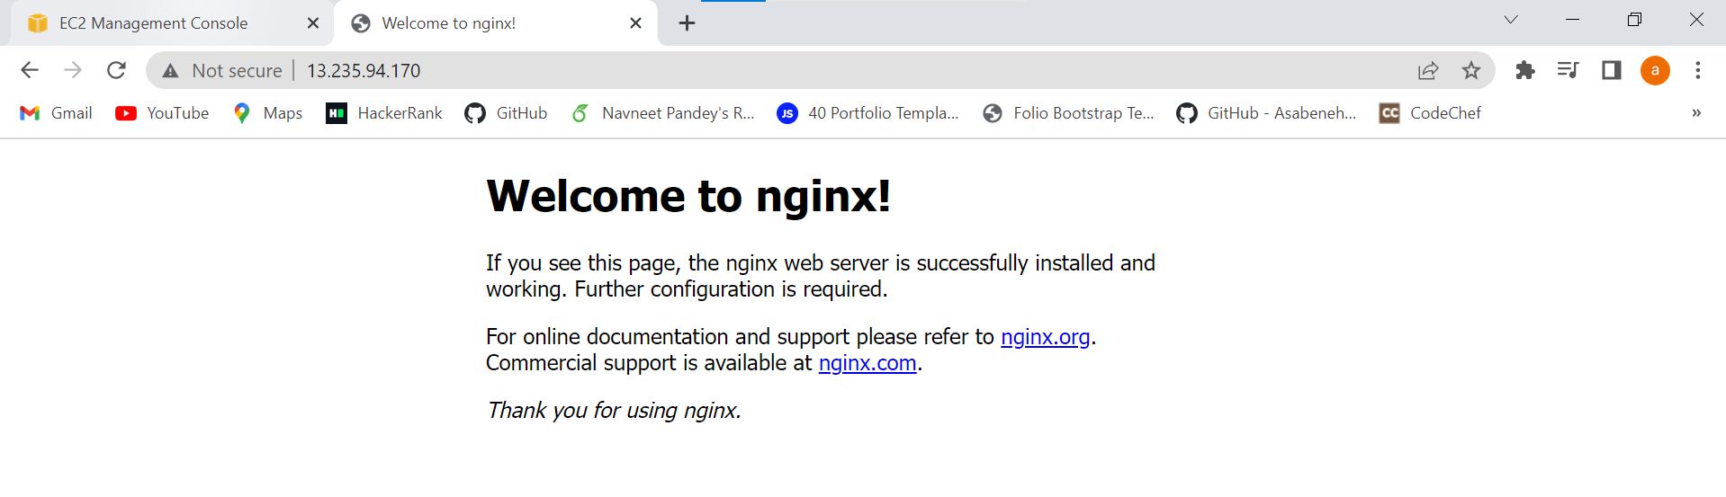

**Creation of Amazon Linux Instance With Bootstrap Script:**

1. Login into AWS account.

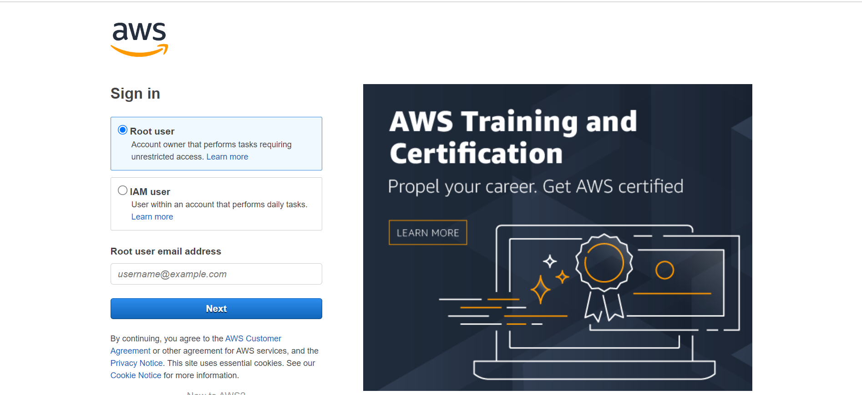

1. Create the instance as follows:

Name the instance.Then in OS images select the amazon linux and select the free tier configuration.

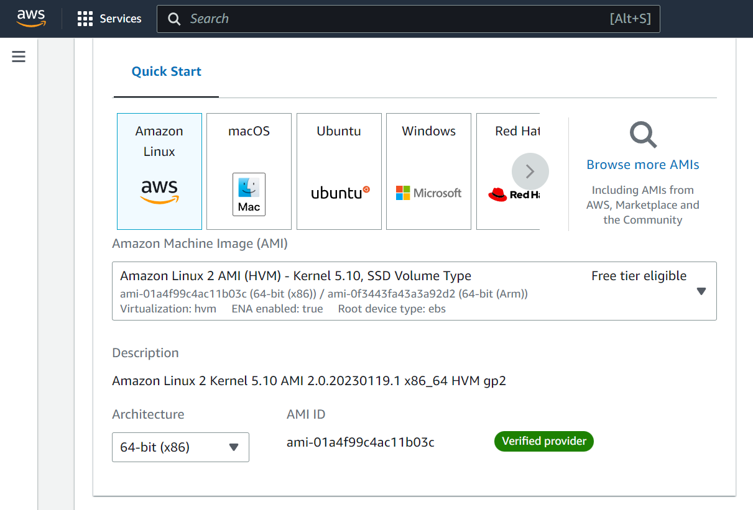

1. Provide the instance type as t2.micro. And create a key-pair, here I am creating a key-pair with name demokey.

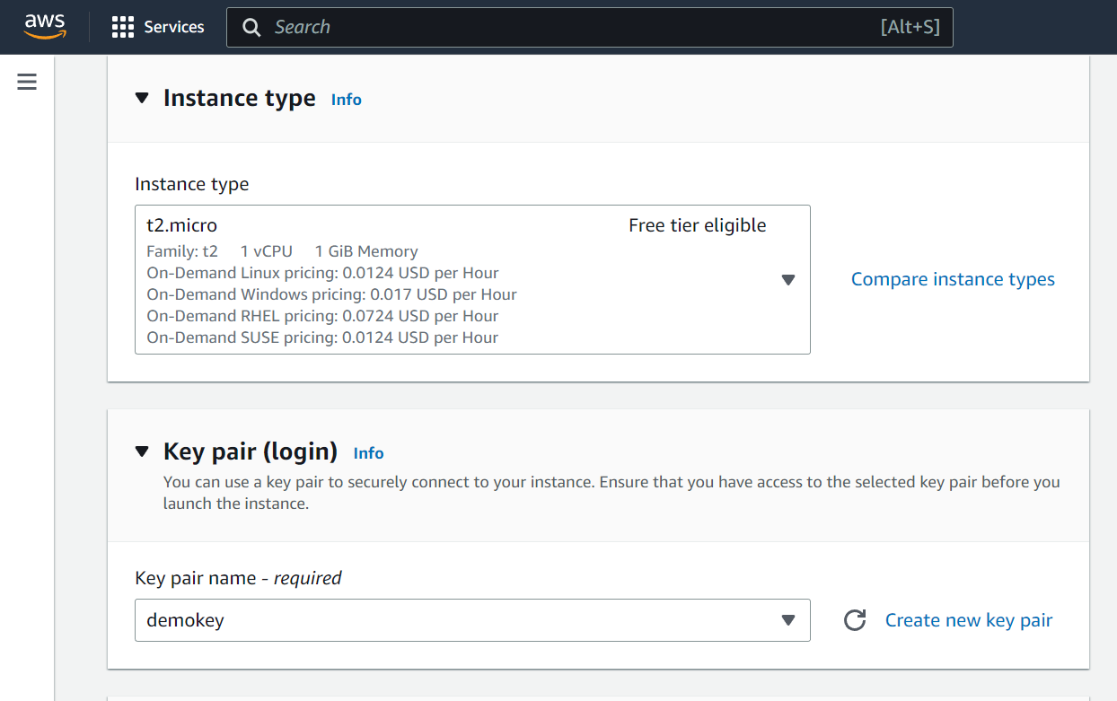

1. In firewall security group allow all the groups.

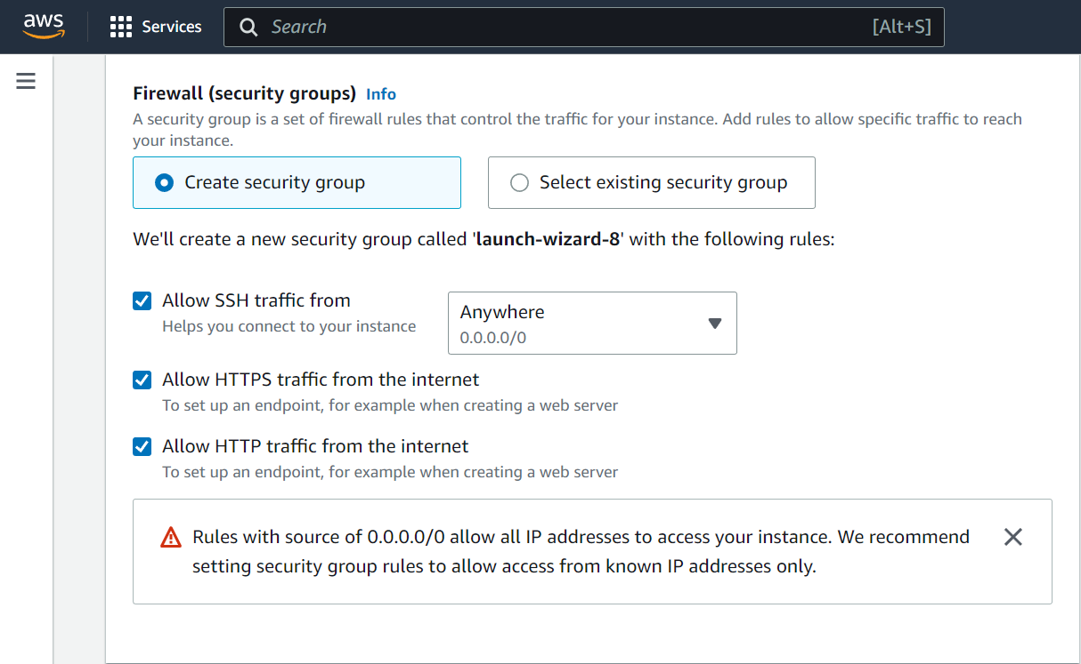

1. In advance details, go to user data and type the following bootstrap script:

#!/bin/bash

sudo su-

yum update

yum install httpd -y

cd /var/www/html

echo “WELCOME” > index.html

service httpd start

(h)<config httpd on

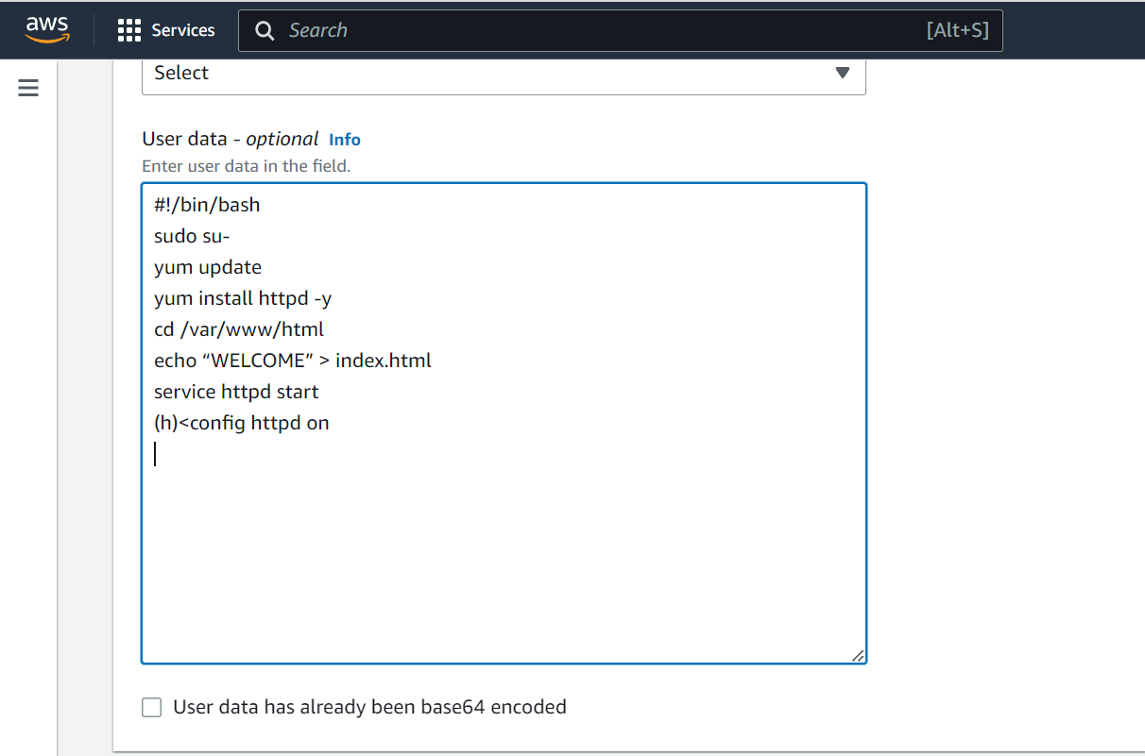

1. Click on launch instance. The instance is created.

This will take some time but the instance is created.

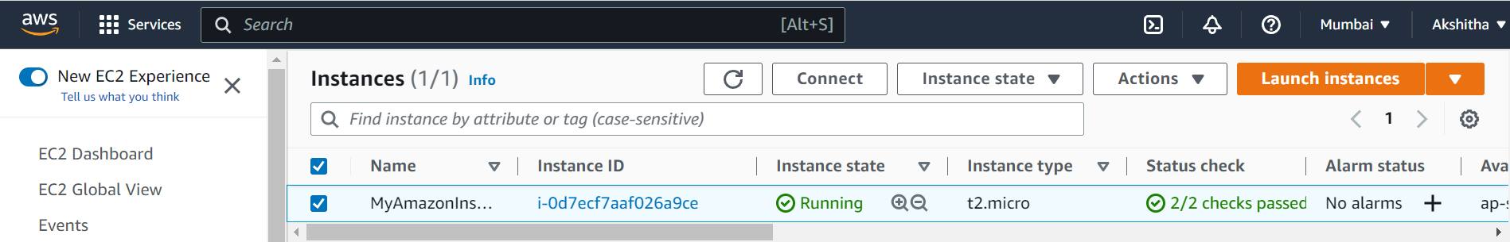

1. Now, the step is to copy the public IP address and paste it in the Google tab the html code we have created is displayed over the page.

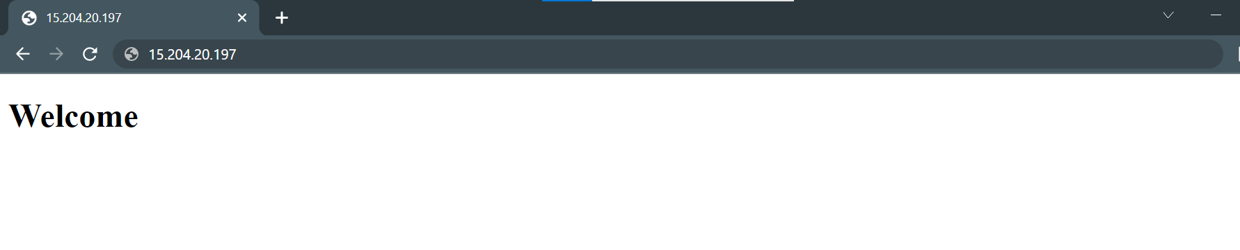

1. Now terminate the instance.

**Creation of EC2 Instance for Windows OS using RDP connect**

1. Login to the AWS account.



1. We need to launch the instance. Give the instance name.

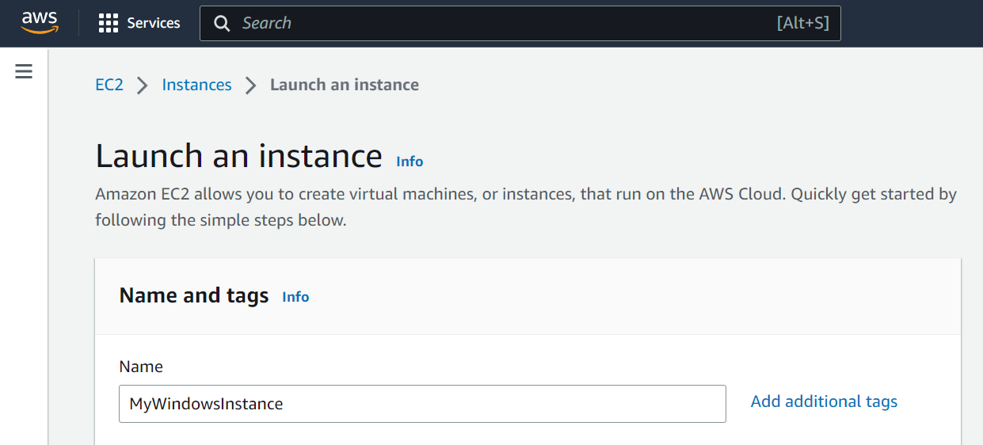

1. In Applications and OS images select the Windows service.

And let the configuration be the default free tier configuration.

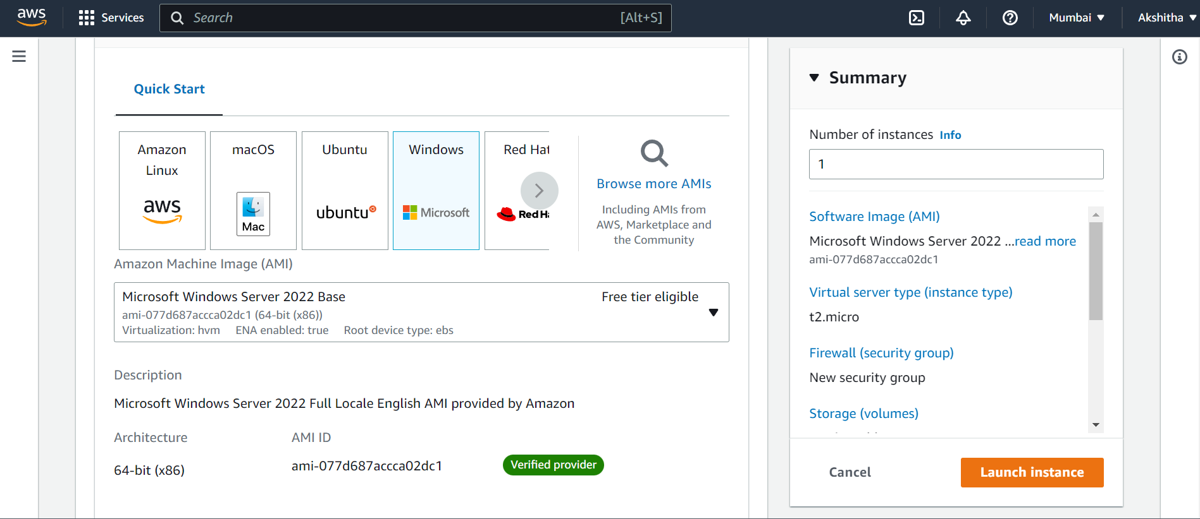

1. Mention the type of the instance as t2.micro and also create a key pair.

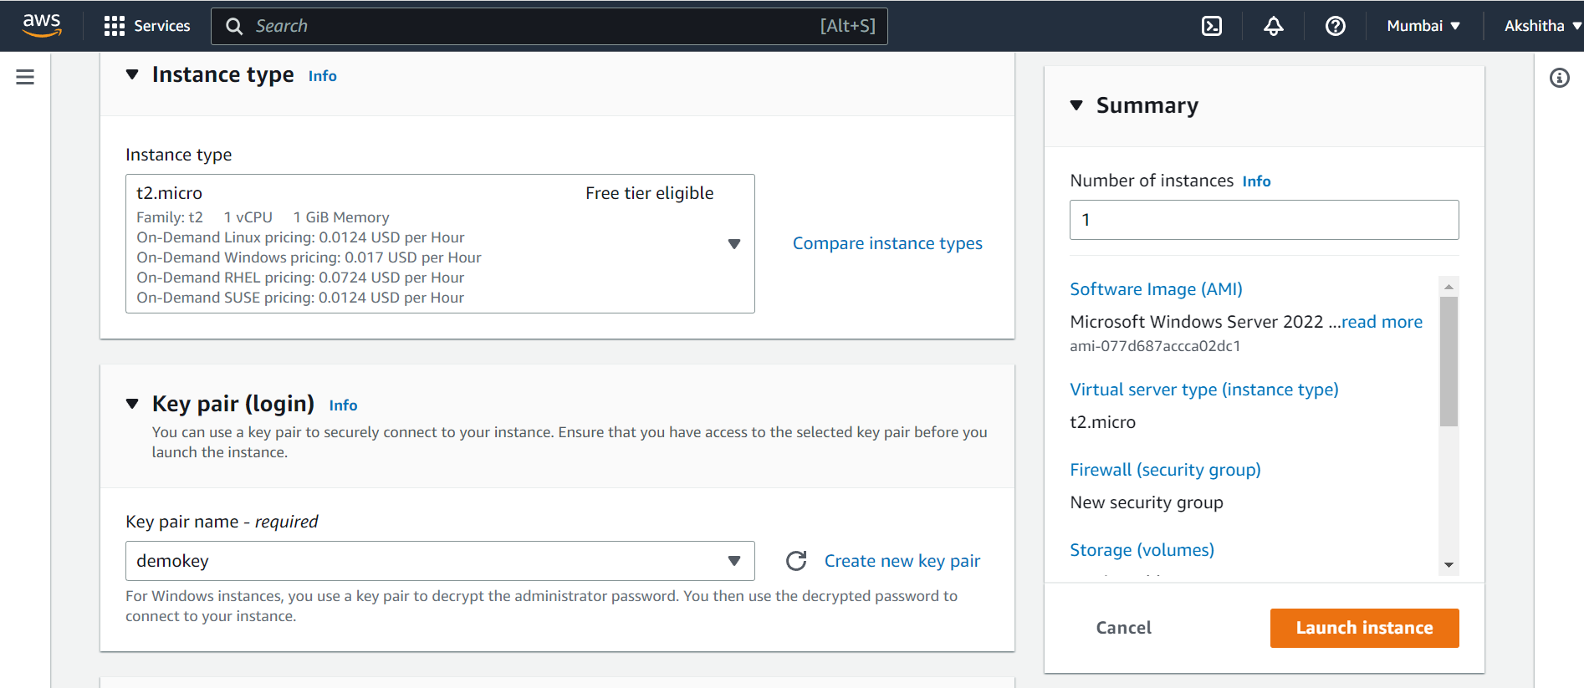

1. In network settings allow all the security groups and click on launch instance.

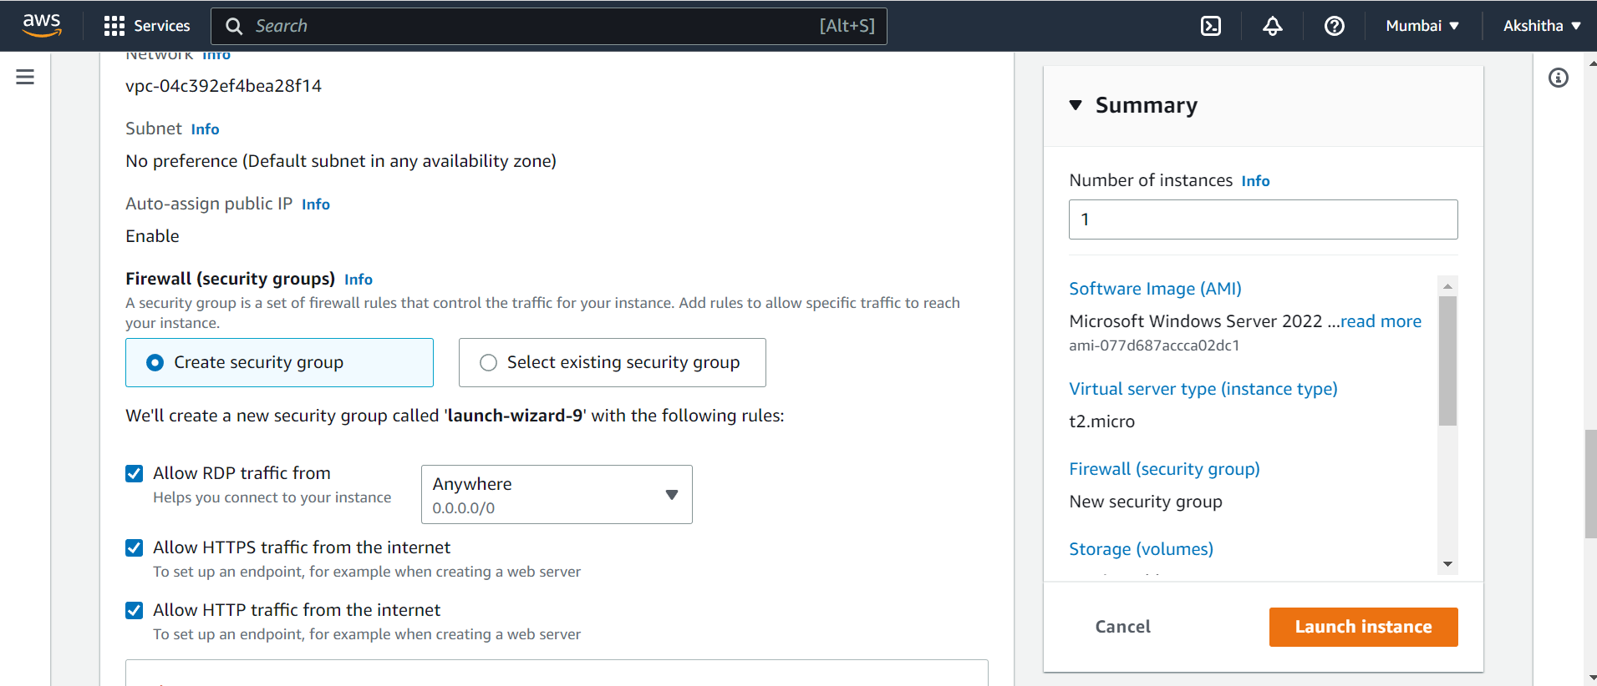

1. Click on connect then a RDP client is visible.

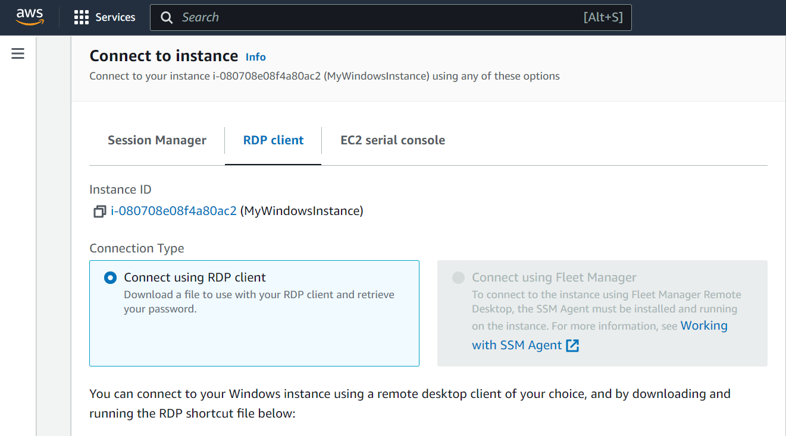

1. Select that and click on download remote desktop file.

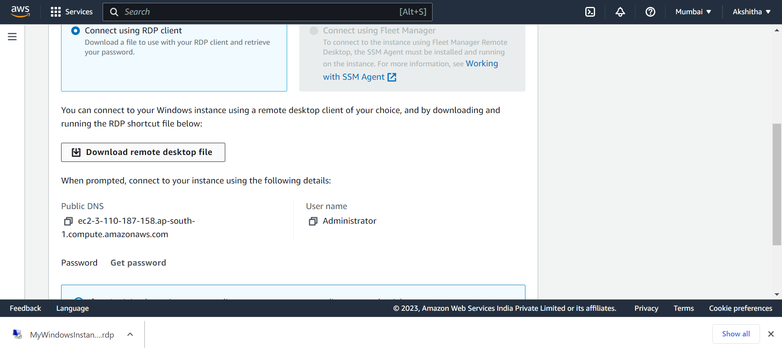

1. We also need the password, so click on get password.

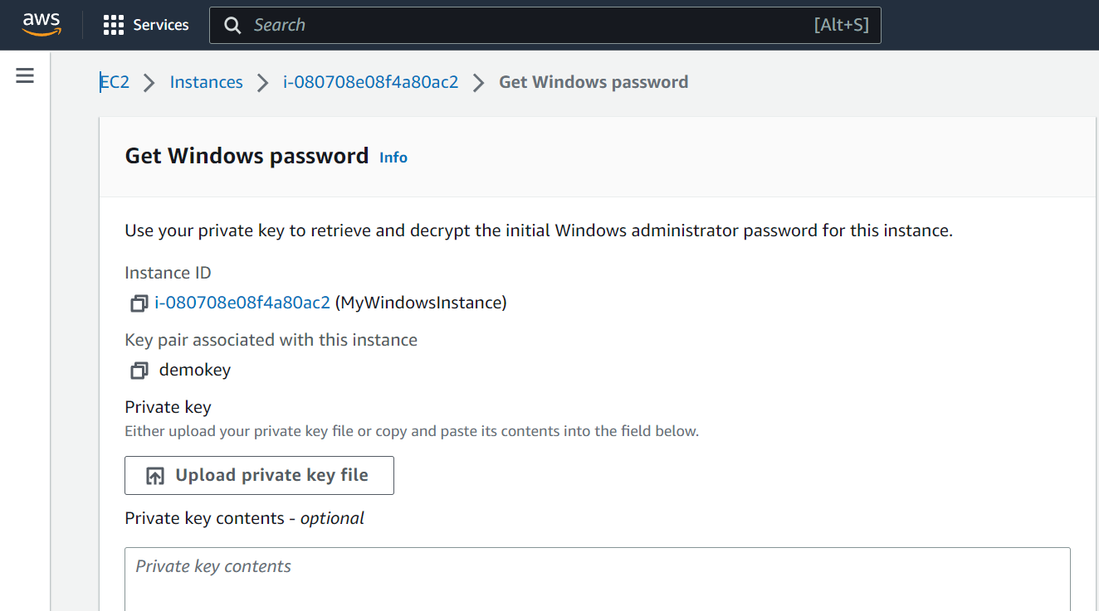

1. Here upload the private key, and click on Decrypt password.

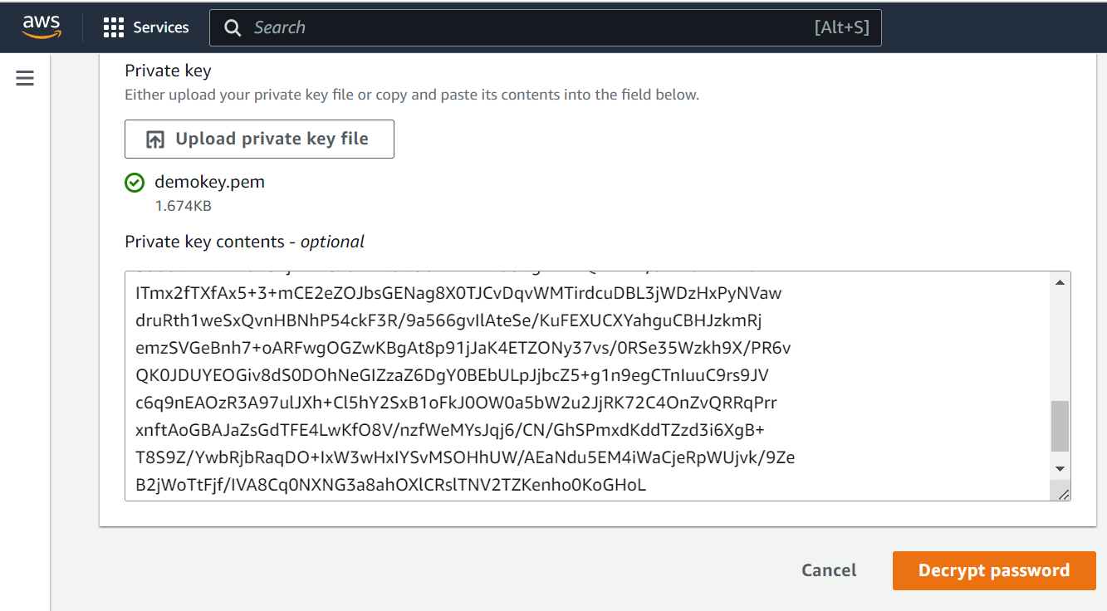

1. A password is generated copy that password into the clipboard.

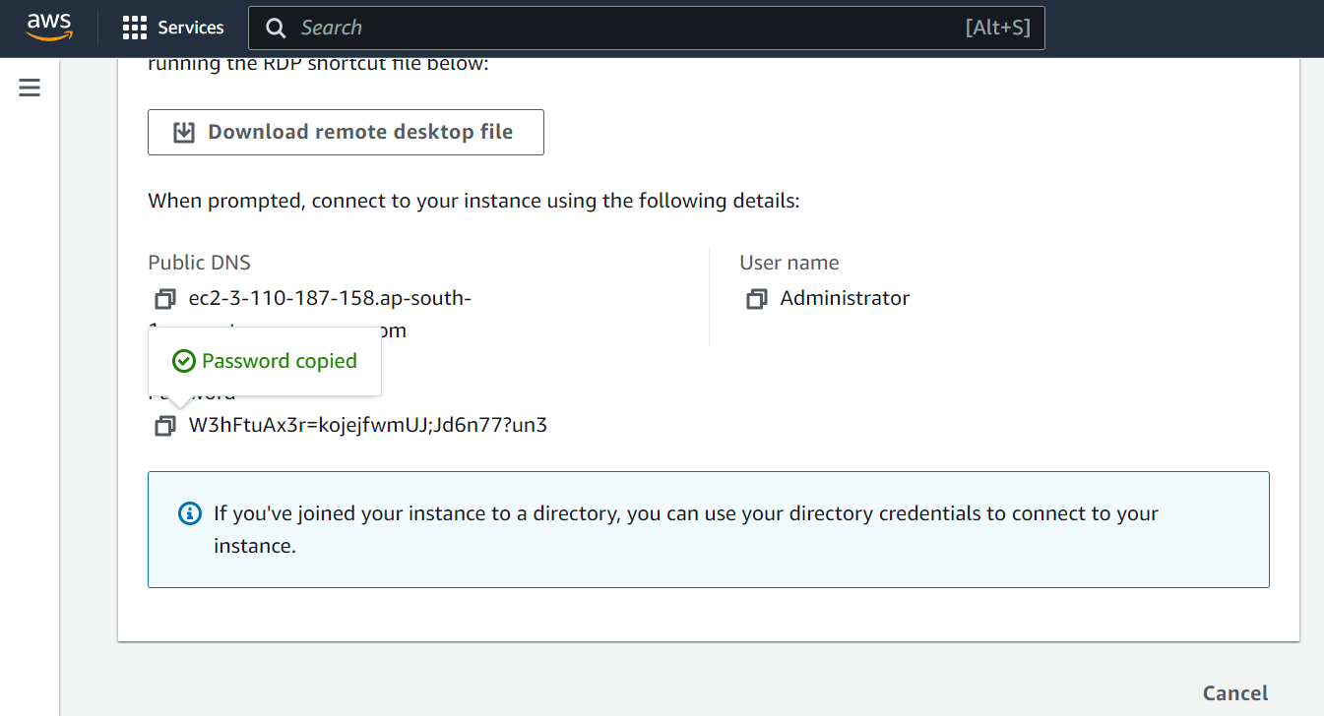

1. Click on the RDP file we downloaded and enter the user name as Administrator and the password we copied in the above step.

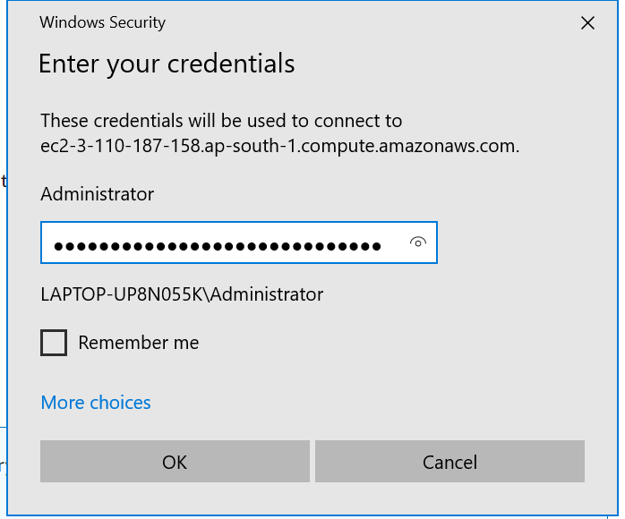

1. The windows server is finally created.

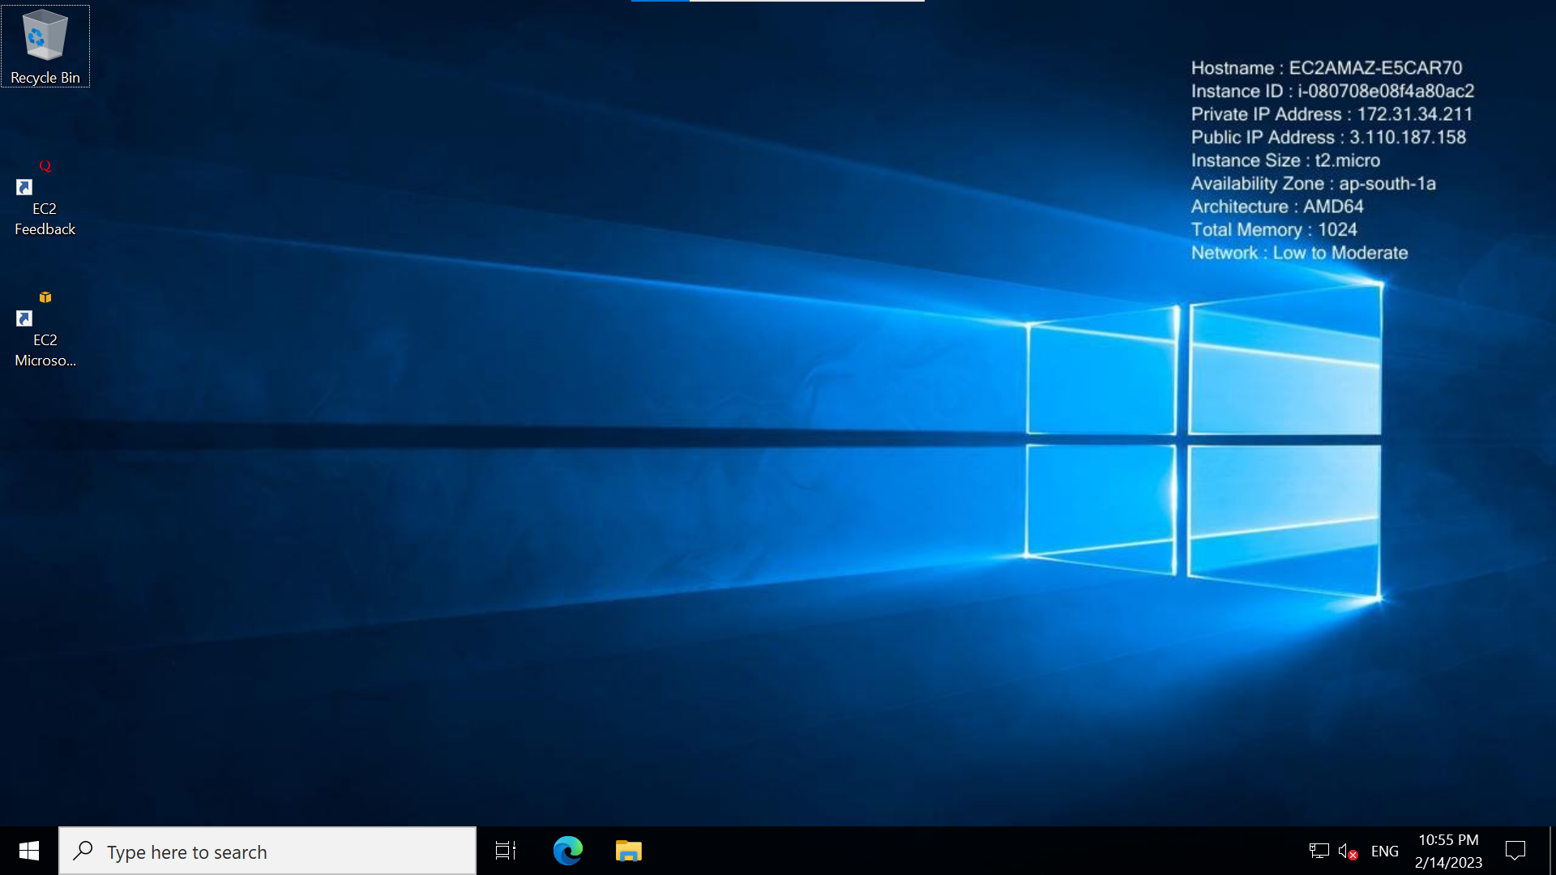

**SNAPSHOT:**

1. Create a EC2 Instance (EBS1) in Mumbai Region with EBS volume as 20GB.

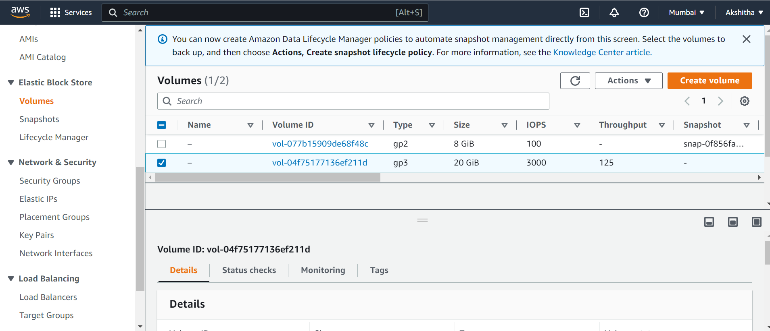

1. Create another EC2 instance (EBS2) in Singapore Region with only root volume.

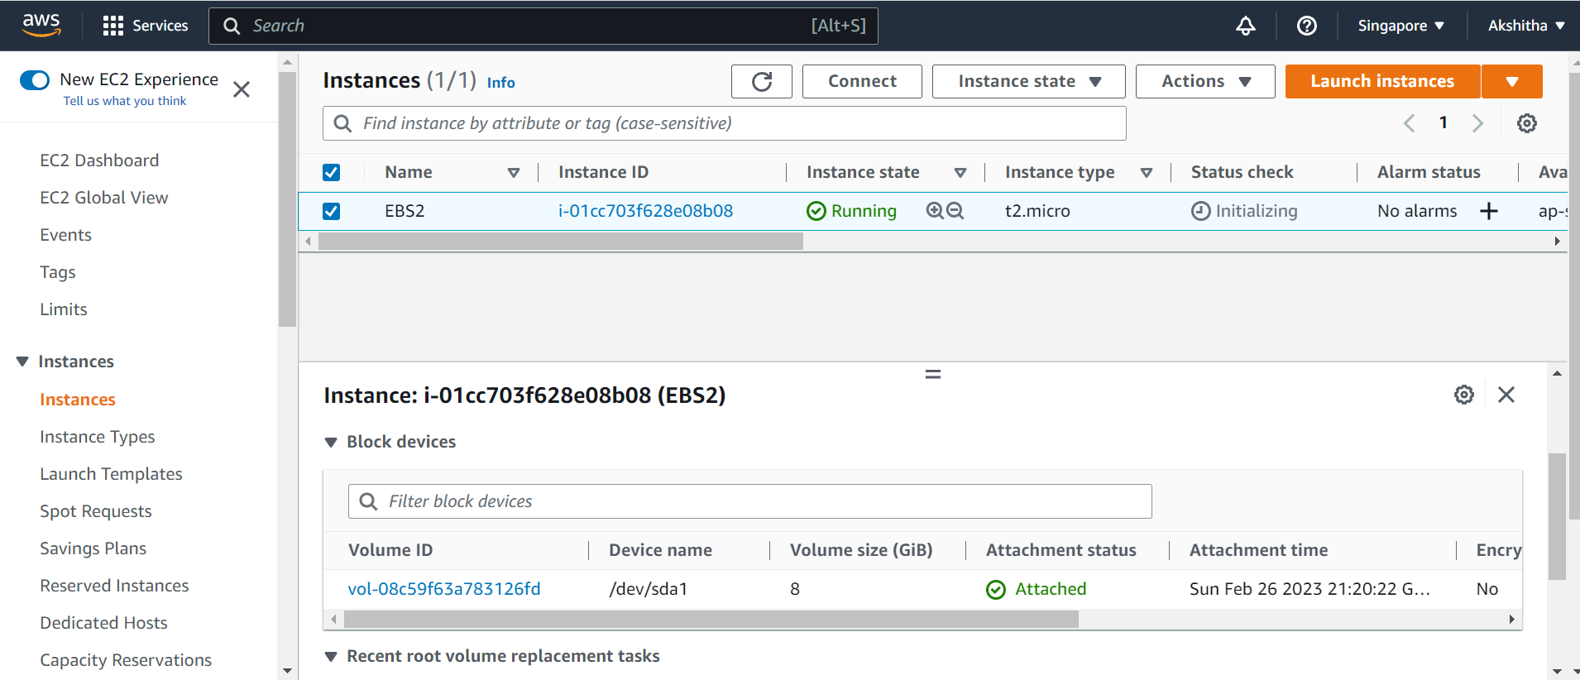

1. In Mumbai region, go to volumes, and select the EBS volume.



1. Click on Actions and then click on create snapshot.

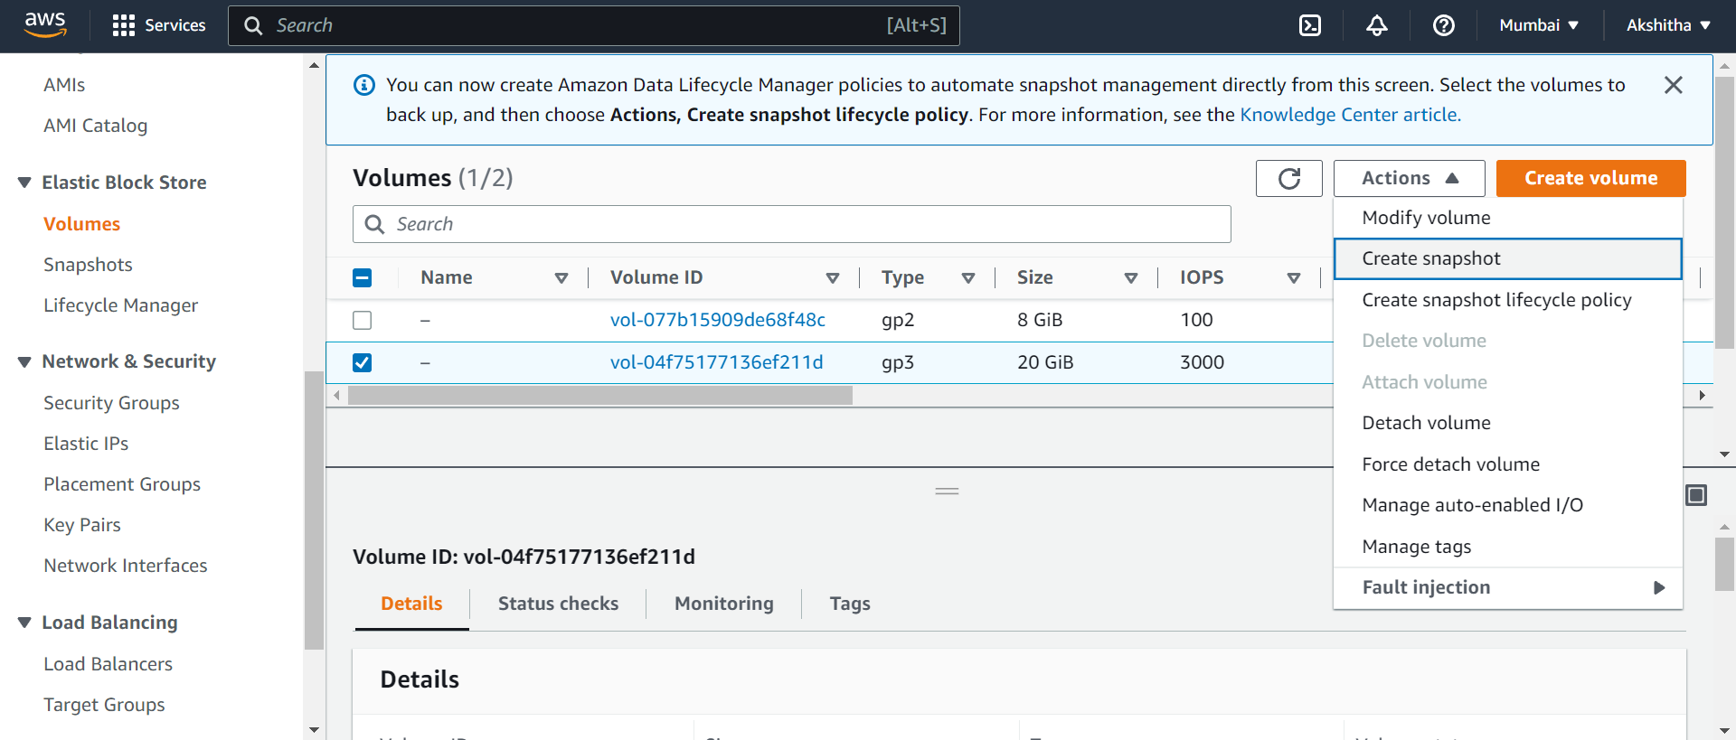

1. Fill the following and click on create snapshot.

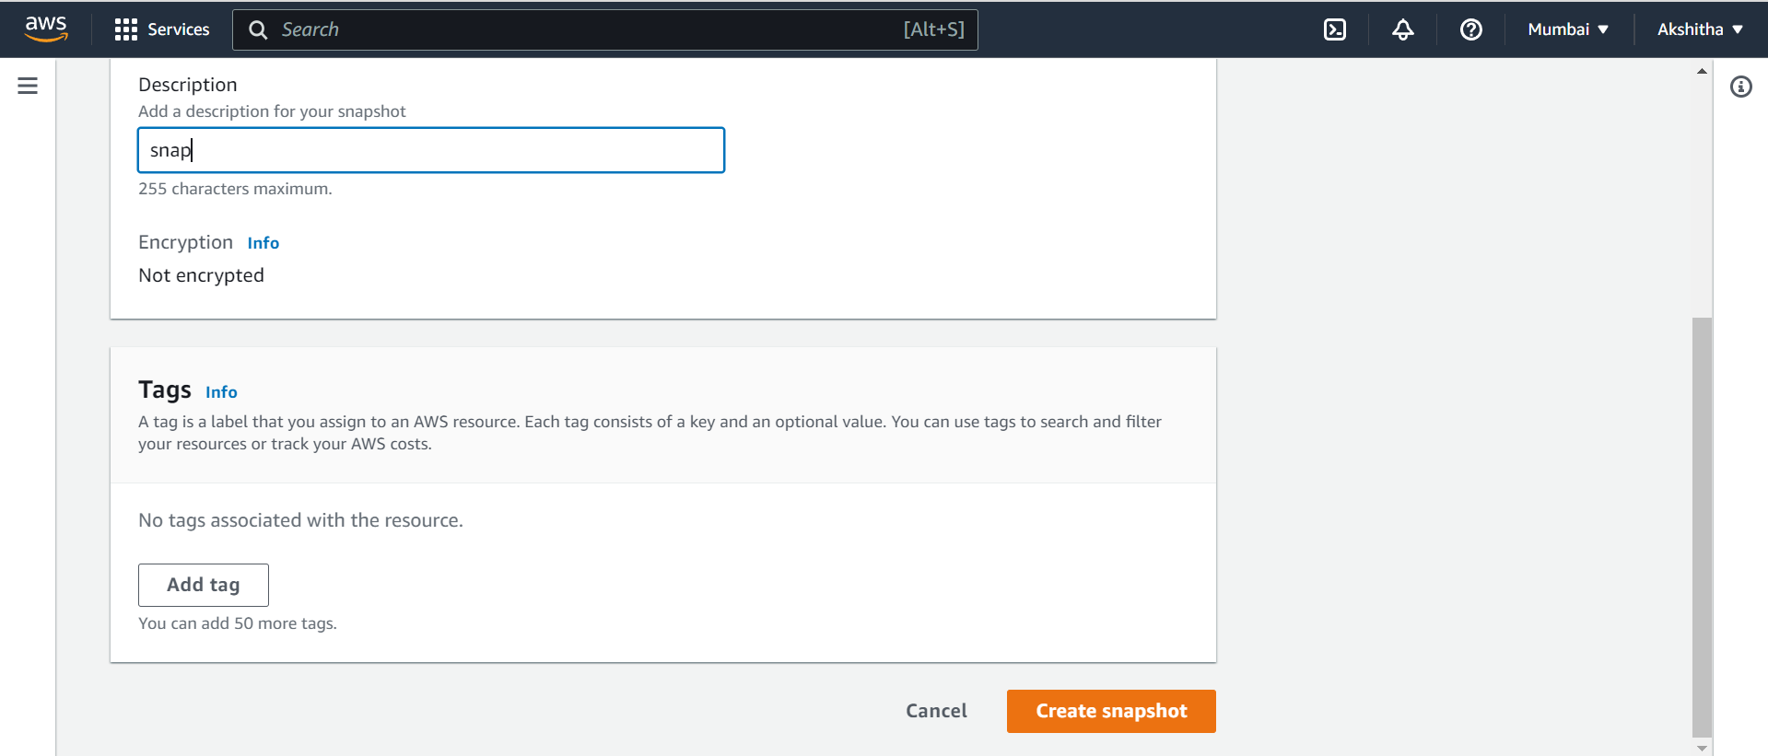

1. Go to Snapshots, and click on actions click on copy snapshot.

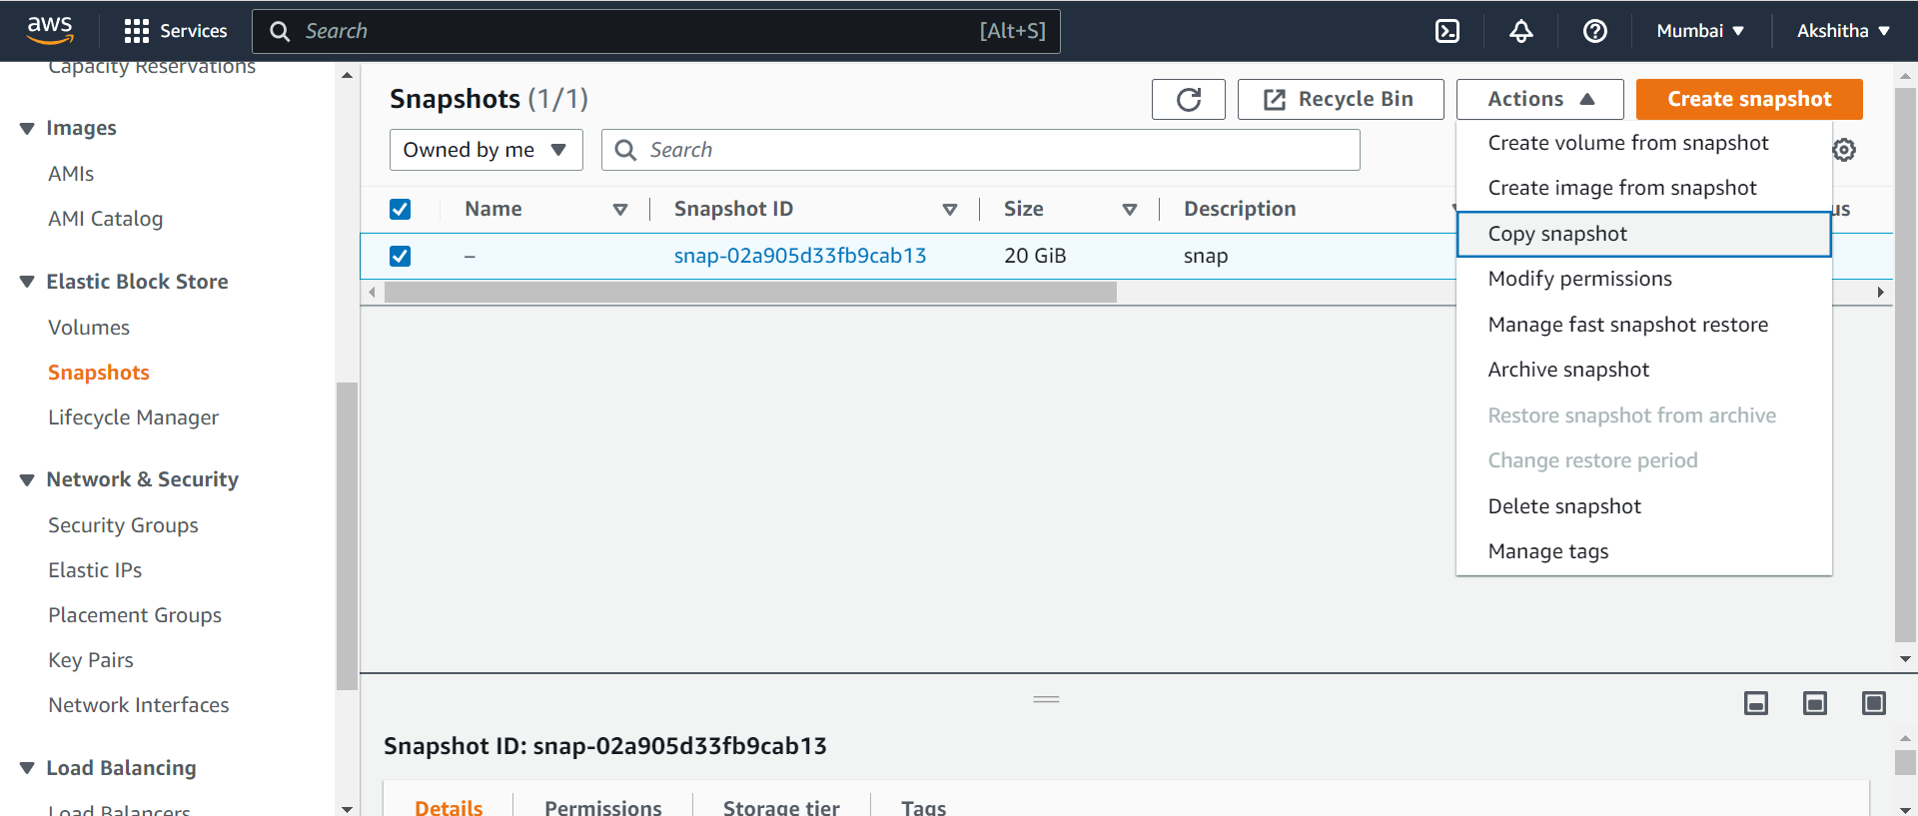

1. Choose the destination region and click copy snapshot.

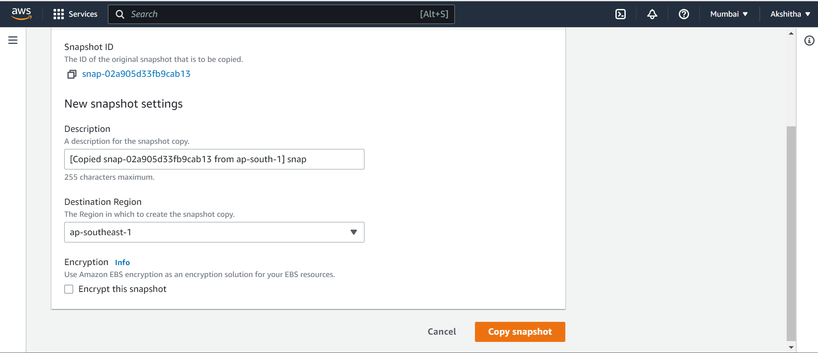

1. The snapshot is copied. Go to Singapore region and open the snapshots and go to actions click on create volume from snapshot.

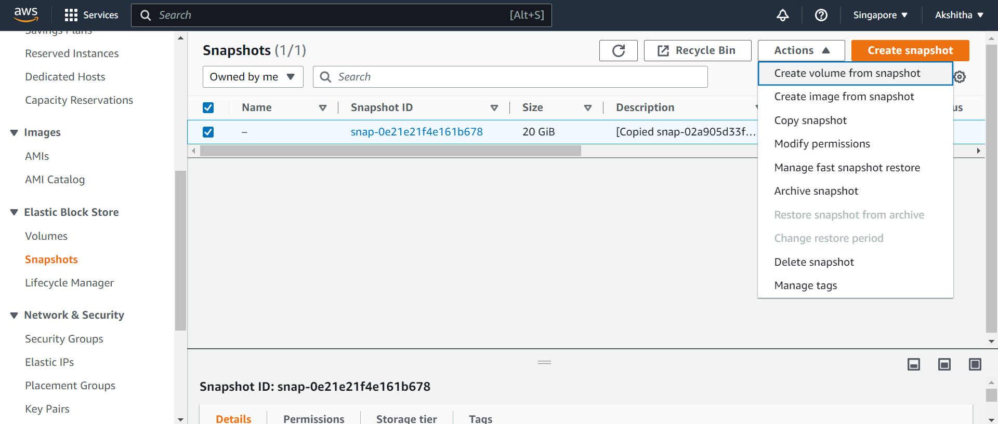

1. Click on create volume from snapshot, then go to Volumes and select the EBS volume and in actions select the Attach Volume.

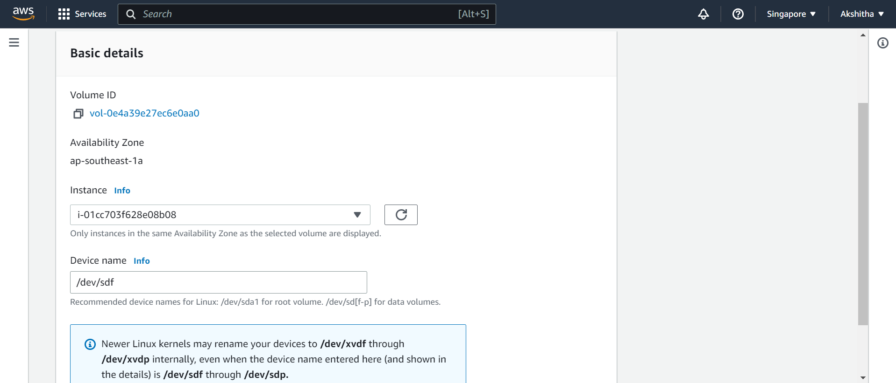

1. After this click on attach volume, hence the EBS volume is attached to Singapore region.

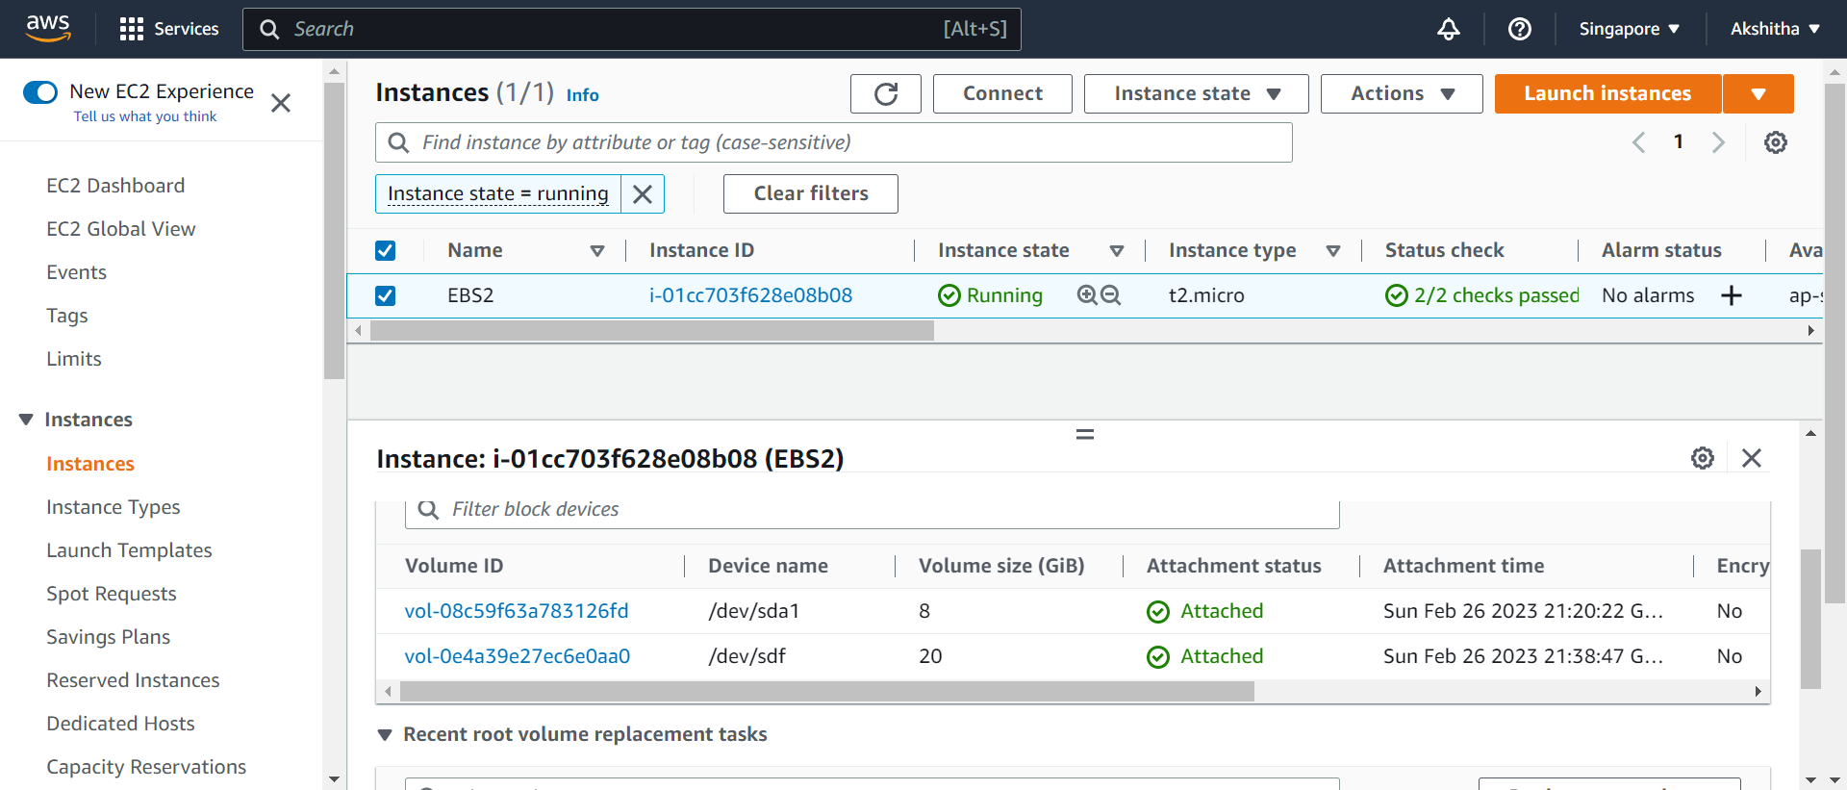

**S3 Bucket:**

1. Open the S3 bucket.

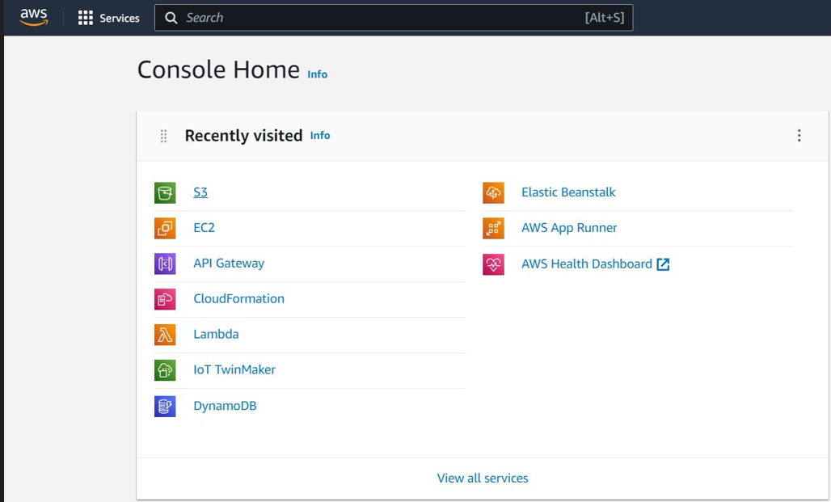

1. Click create bucket.

(Whatever may be the region, the region will automatically set to Global in S3 bucket.)

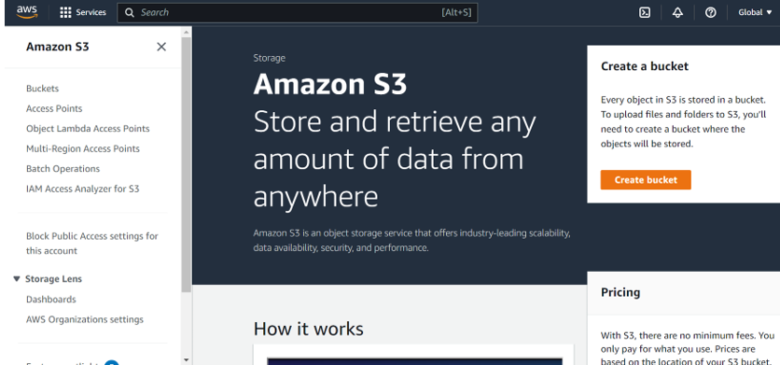

1. Click on create bucket.

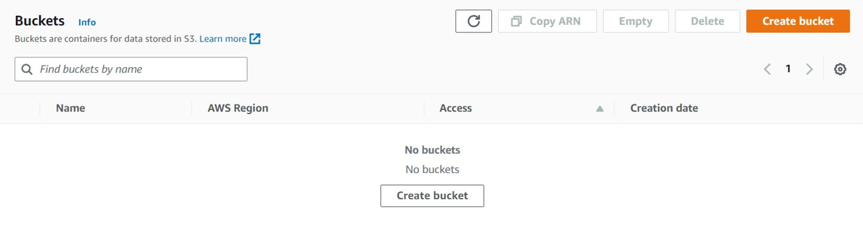

1. Complete the required details.

Give the bucket name.

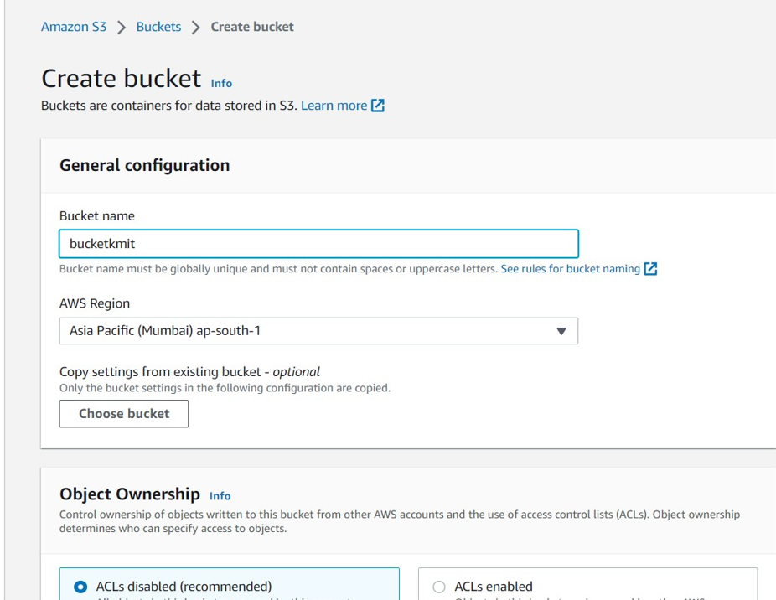

Enable ACL’s

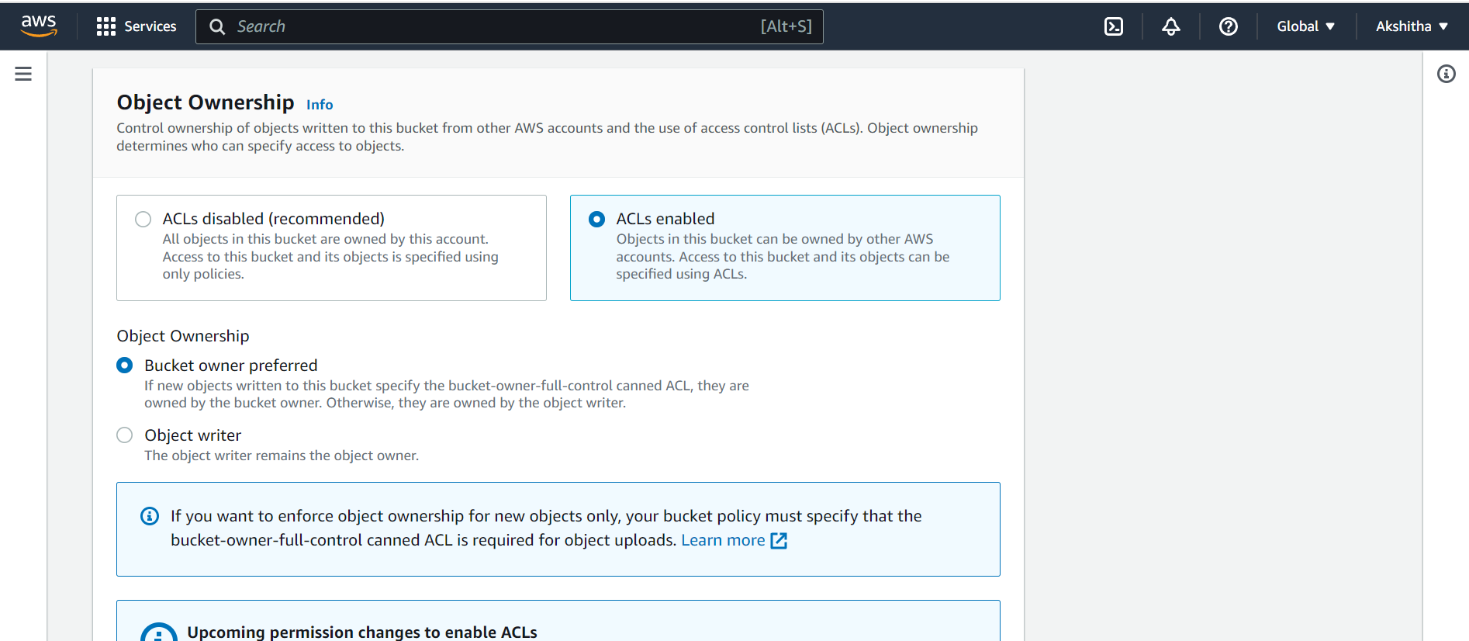

Make the bucket public.

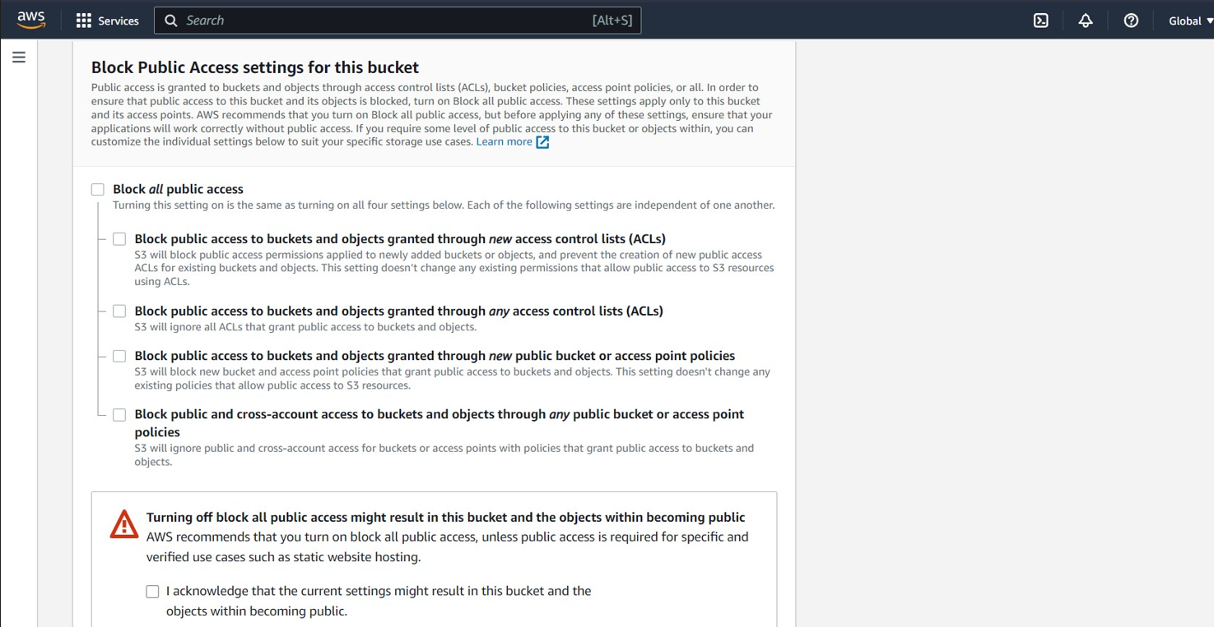

Click on create bucket.

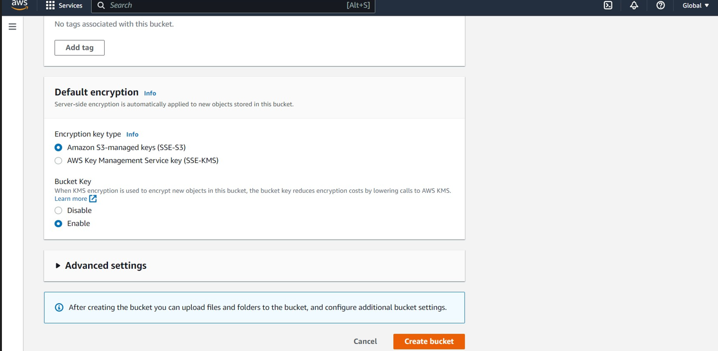

1. Bucket is created with no objects.

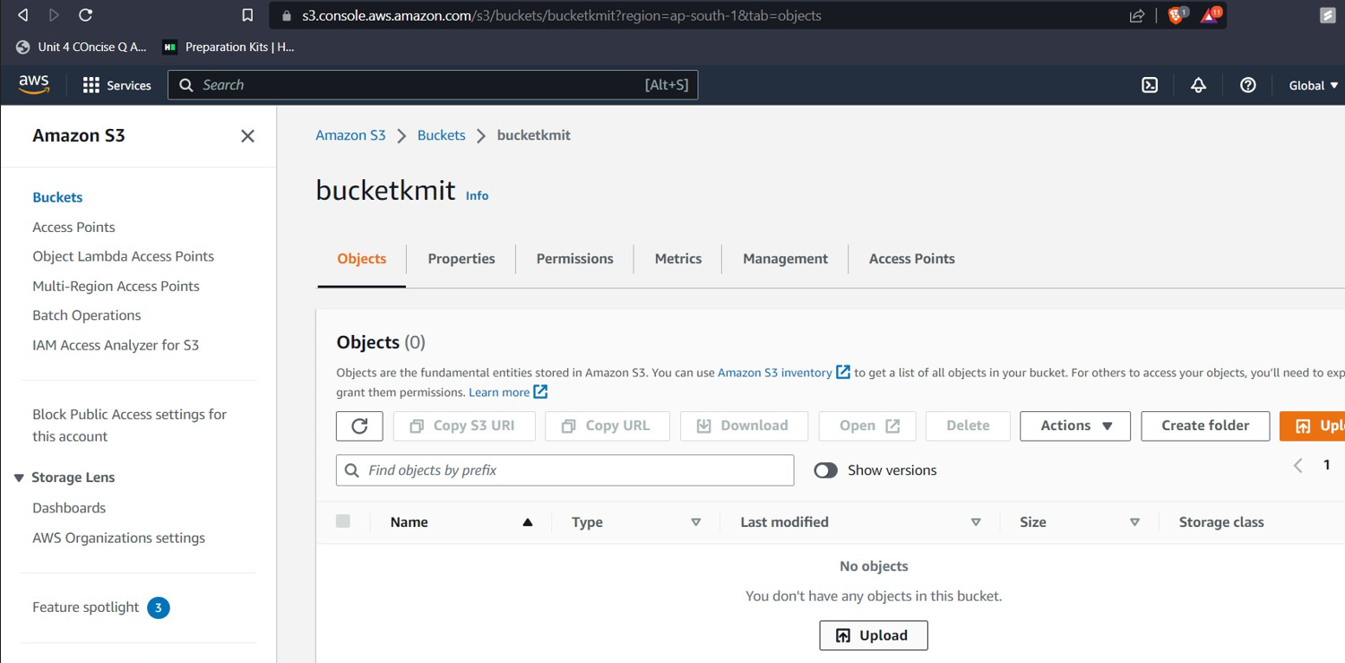

1. There are no objects. Click on Upload and add files, and click on upload.

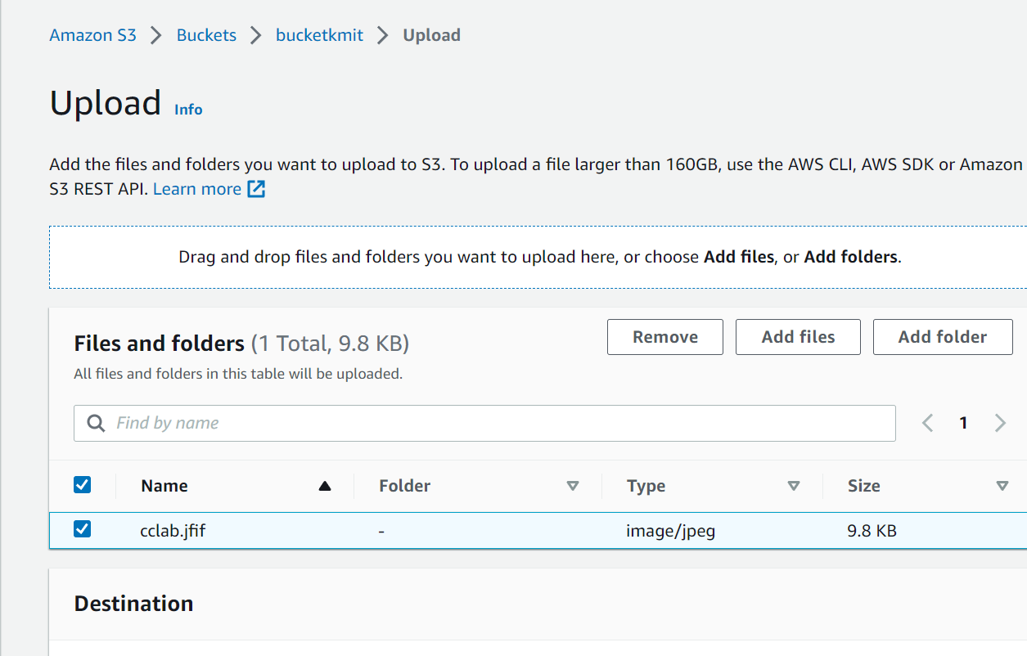

1. An object in bucket is created.

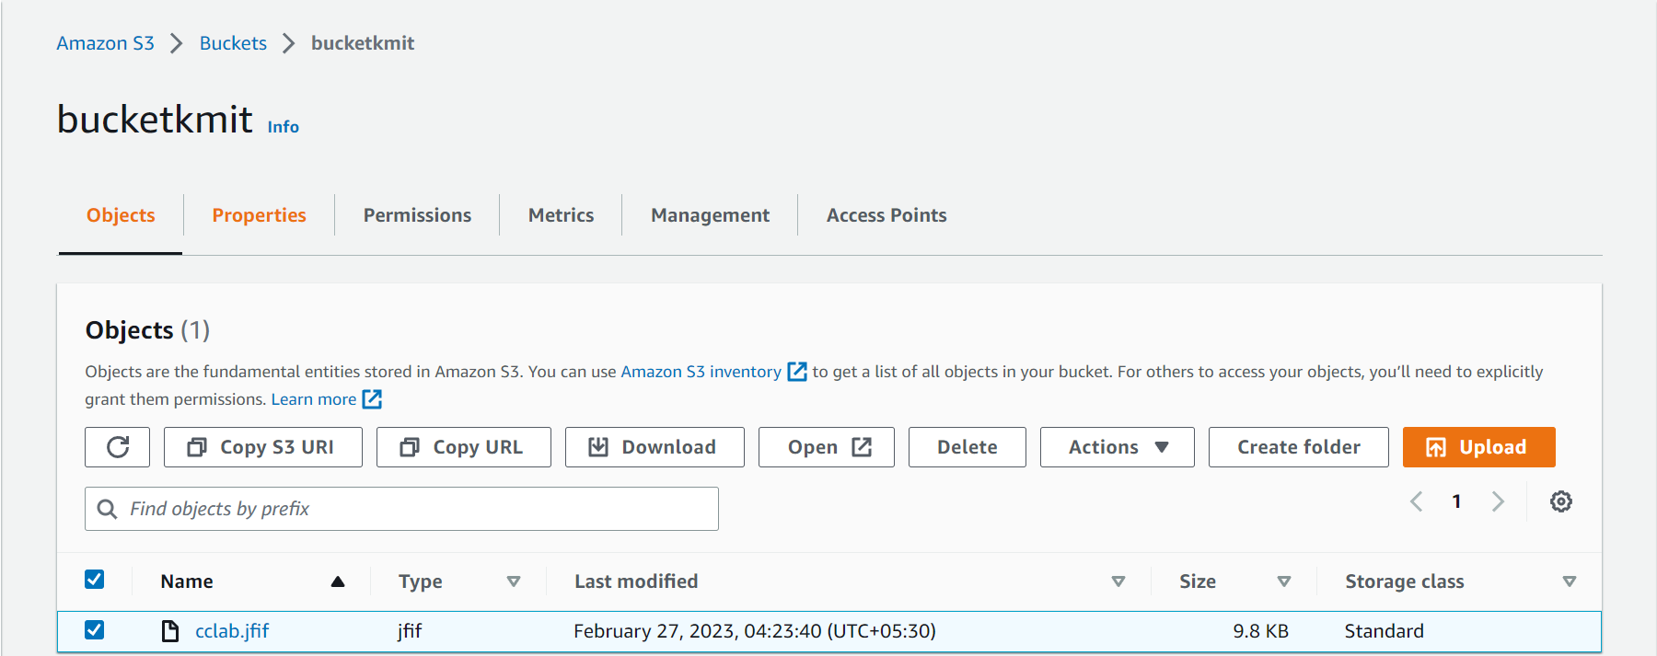

1. Click on object name, go to properties, all the information of that object can be seen, there copy the object URL and paste it in new tab.

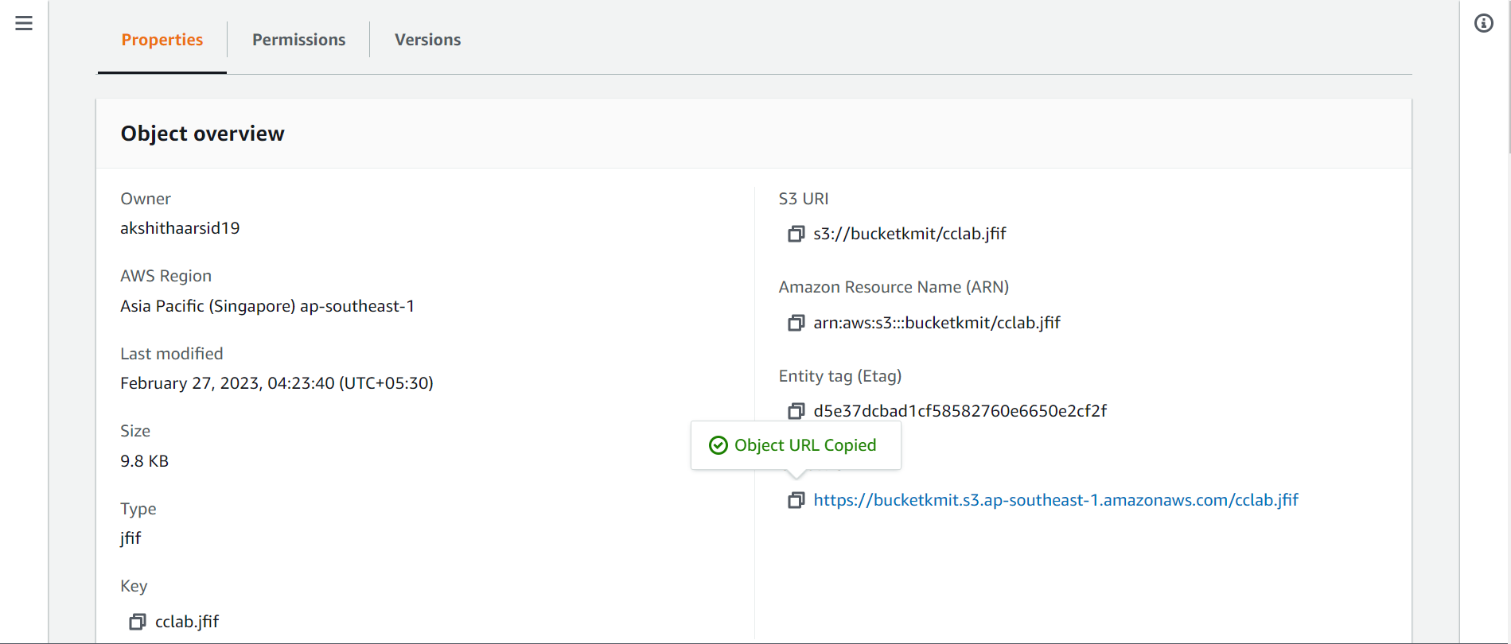

1. An error can be observed.

This error occurs since we didn’t made the public access enabled to the object.

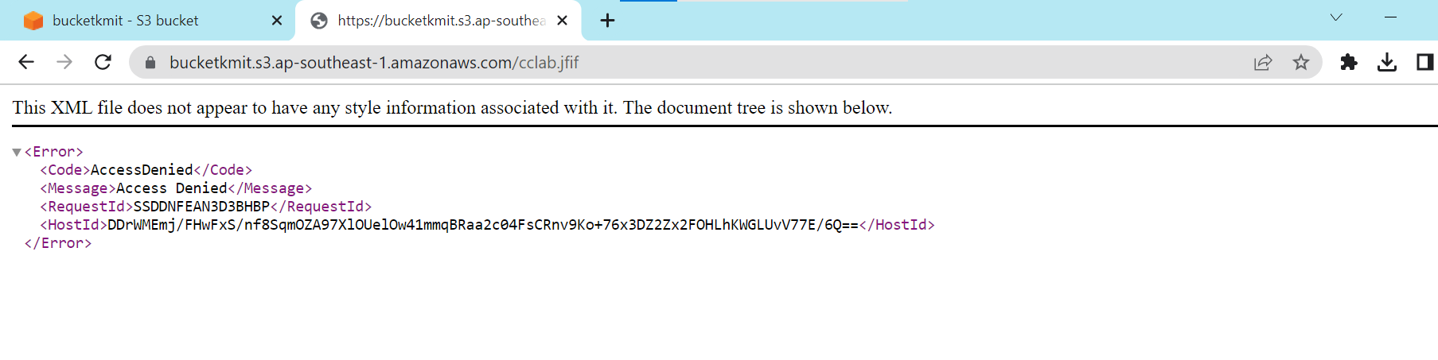

1. Click on permissions, click on edit.

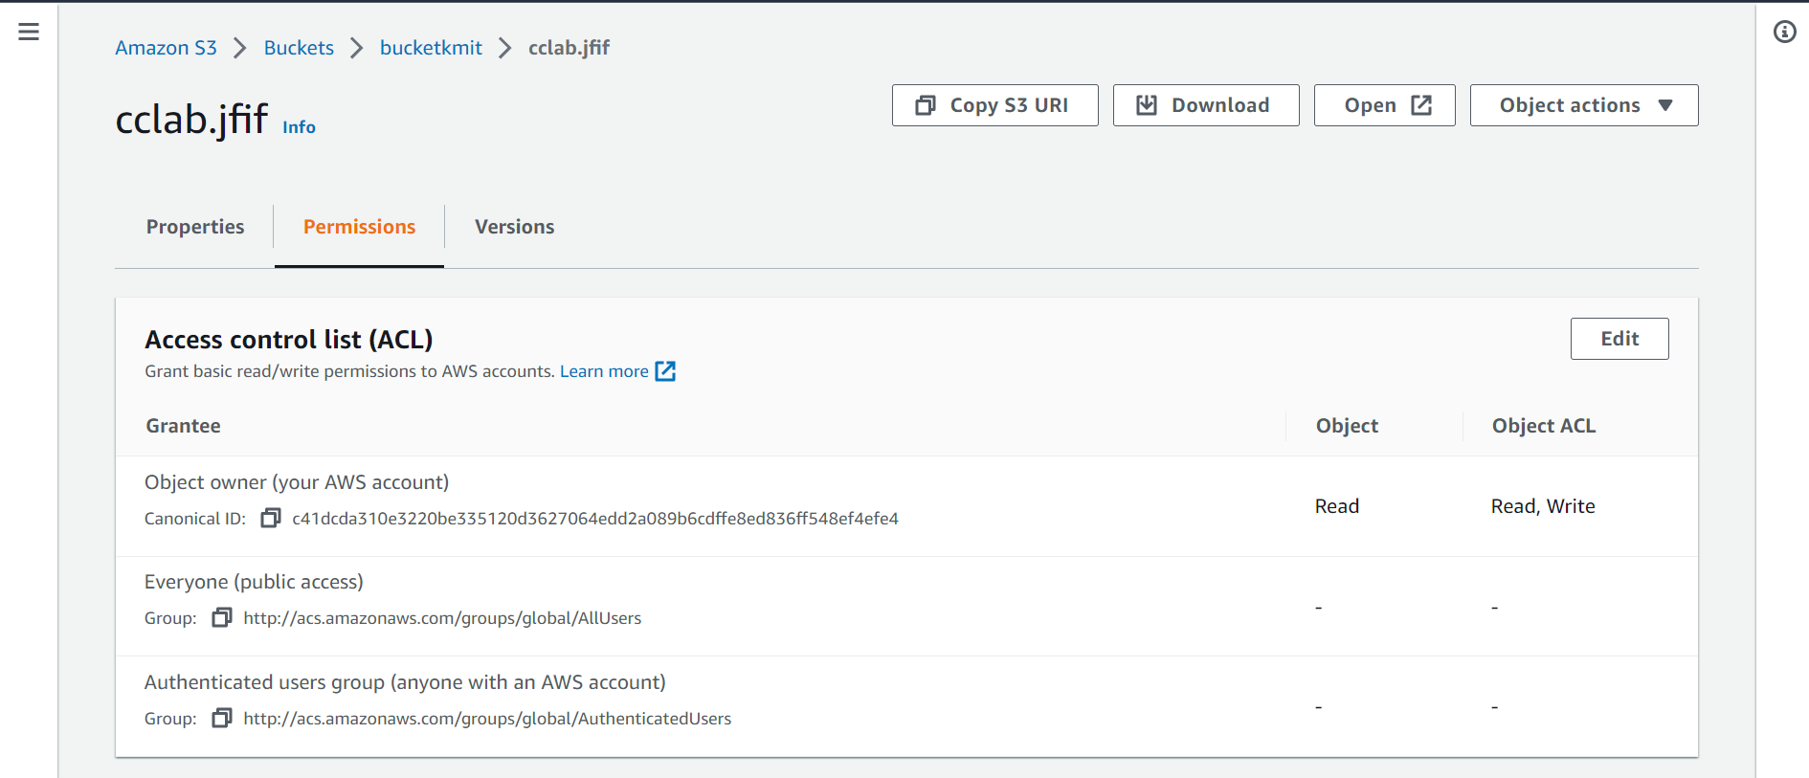

1. Enable the public access and check on the acknowledgment checkbox and click save changes.

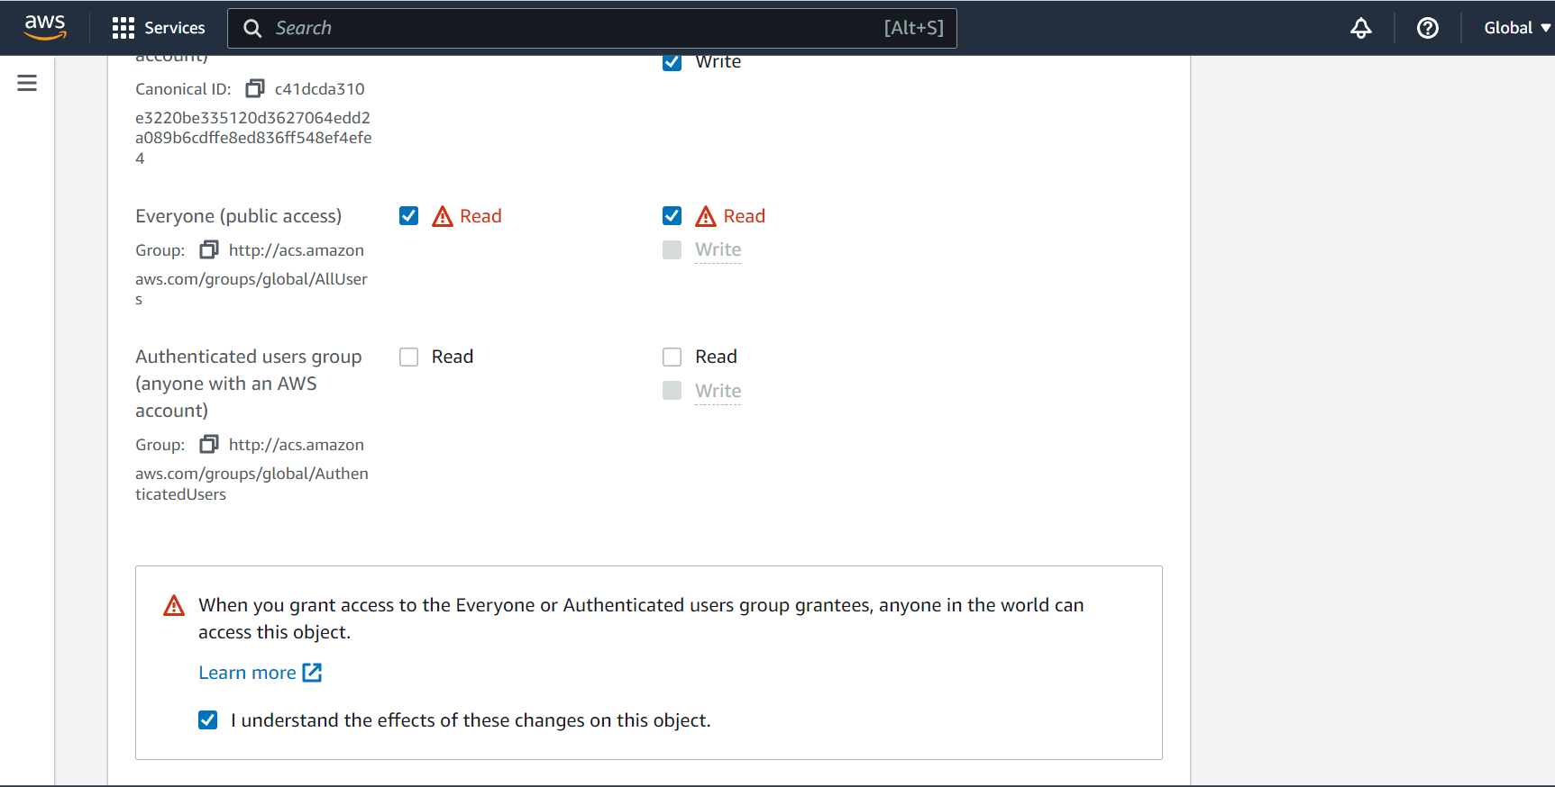

1. Refresh the page and the uploaded object can be seen.

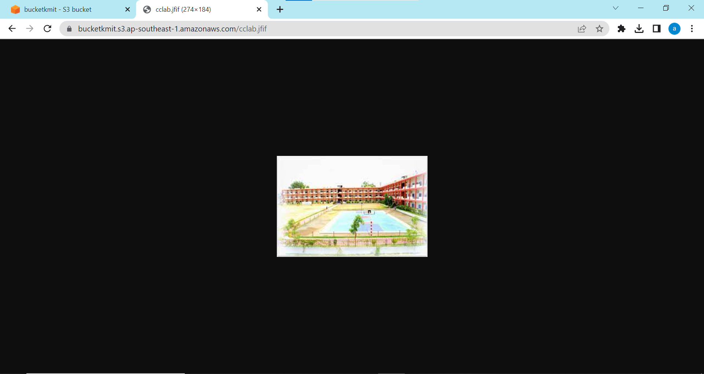

*Versioning:*

1. Click on buckets, go to bucket versioning and click edit.

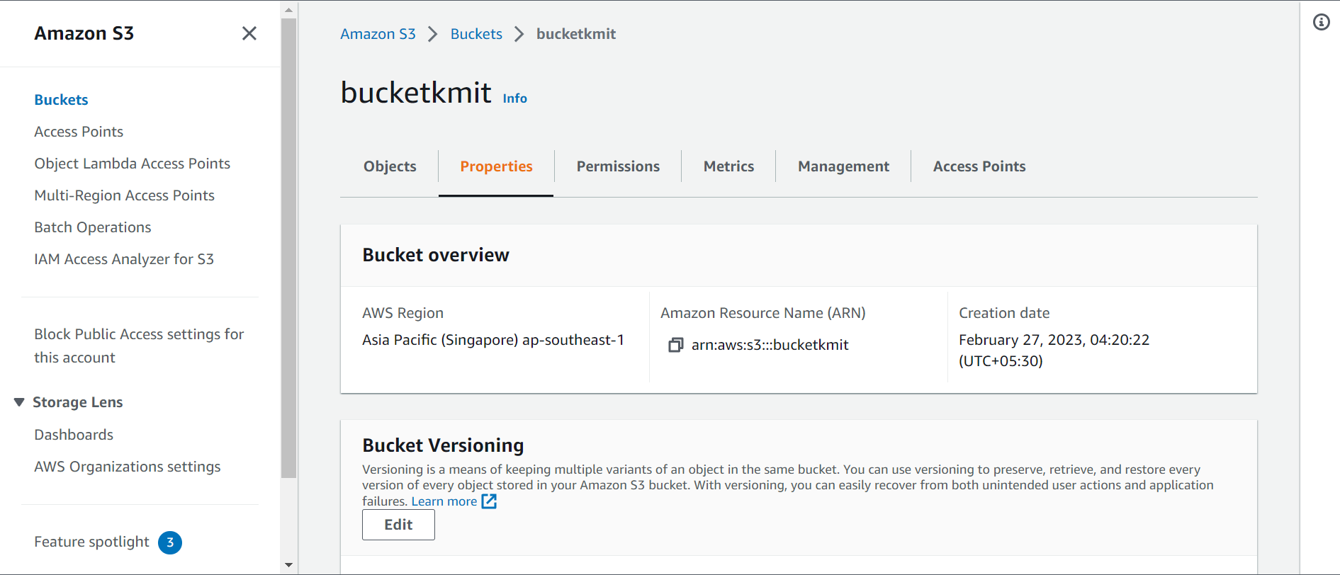

1. Enable and click on save changes.

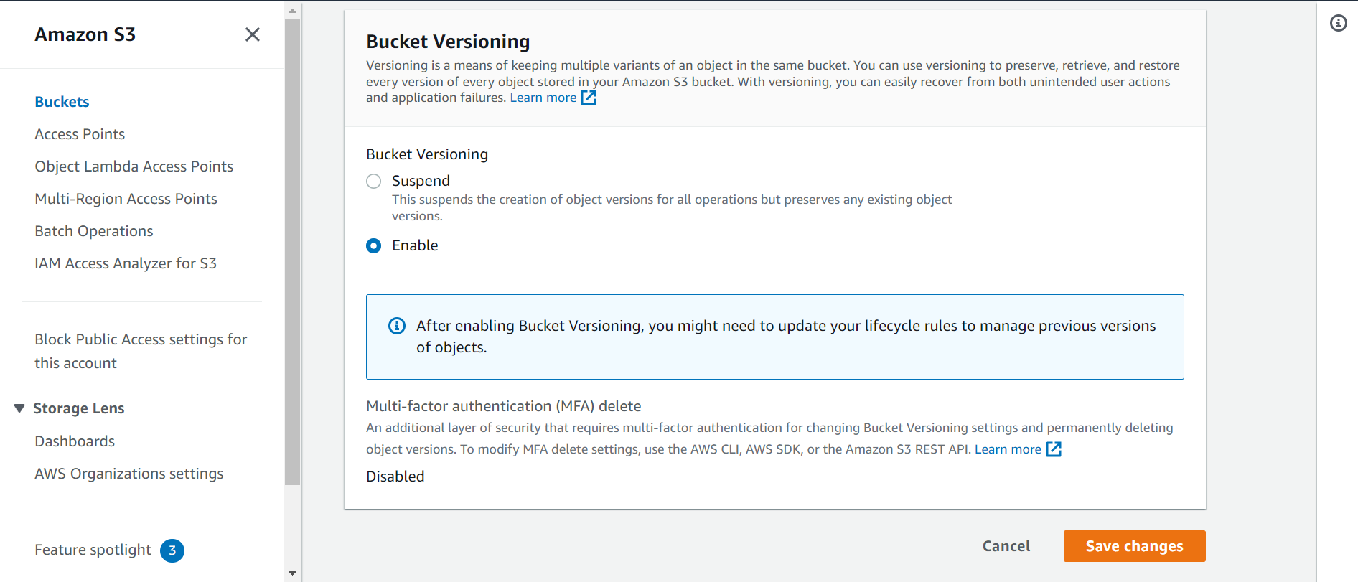

1. If we delete the object and want to restore it, then the we need to use versioning. In simple words, it is like Recycle bin.

Here, delete the object.

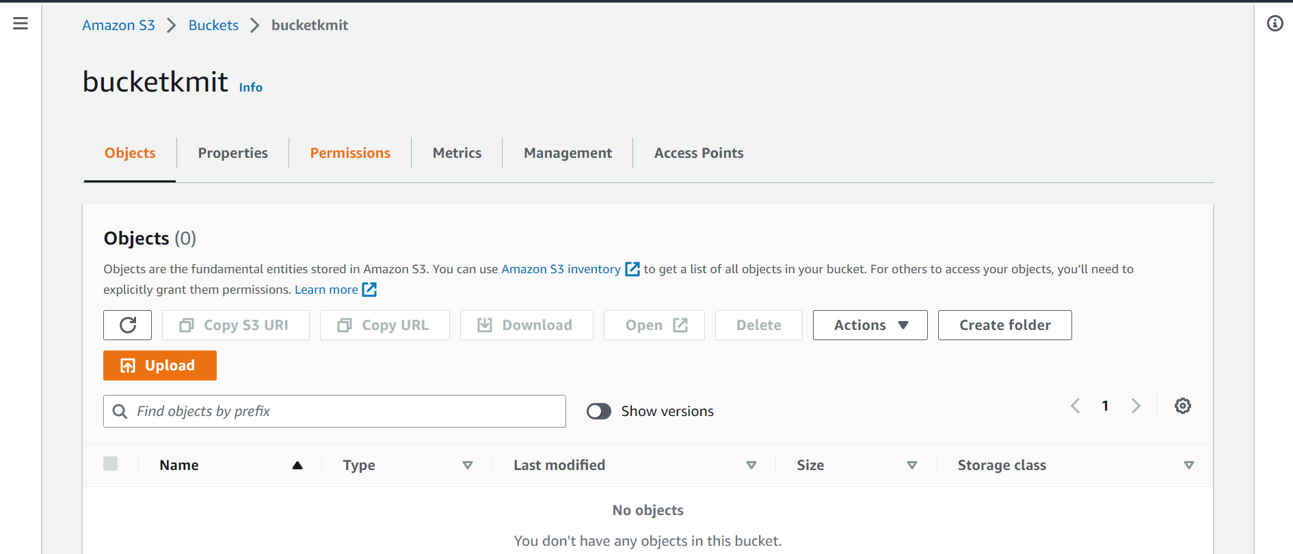

1. Now click on show versions and we can observe the deleted object there.

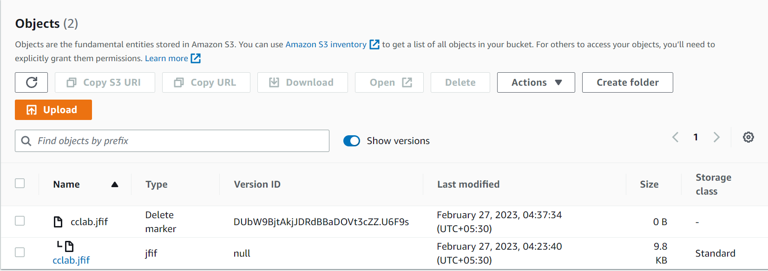

1. Click on the name with type delete marker and then delete the object is restored.

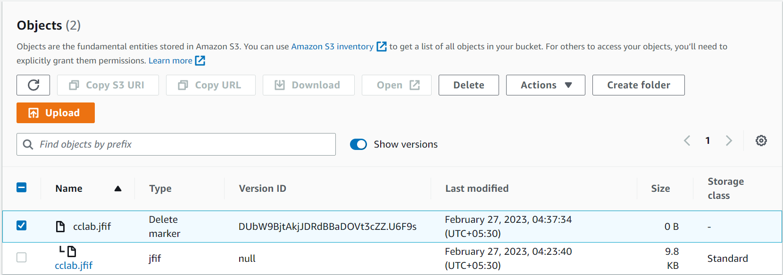

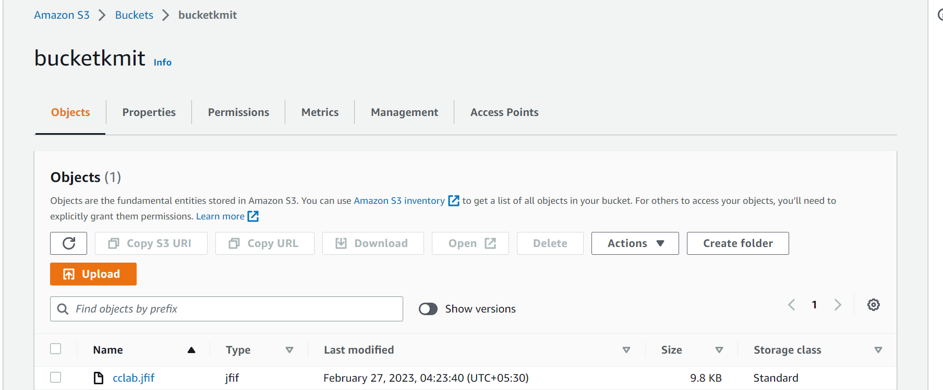

1. We can even add the files and maintains its versions.

Upload any file, here text file is getting uploaded.

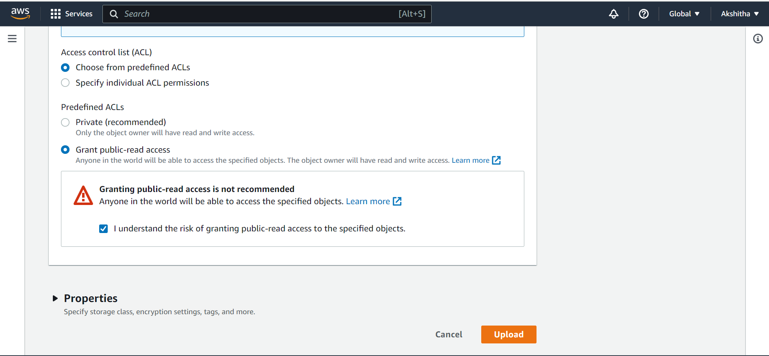

1. Open the object and copy the object URL and paste in new tab.

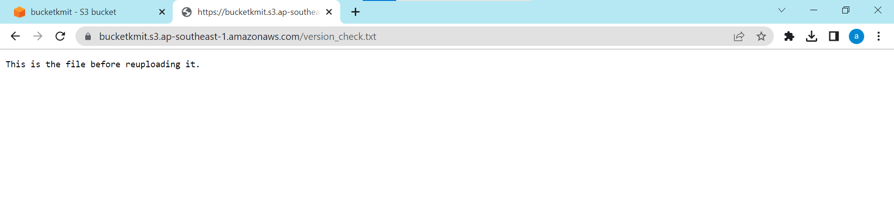

1. Now do some changes in the text file and re-upload it in the bucket.

We can observe only one object, since the previous one is over-written.

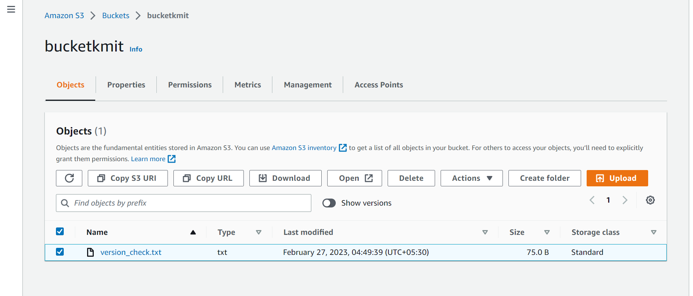

1. Click on show versions, the previous version can be seen in it.

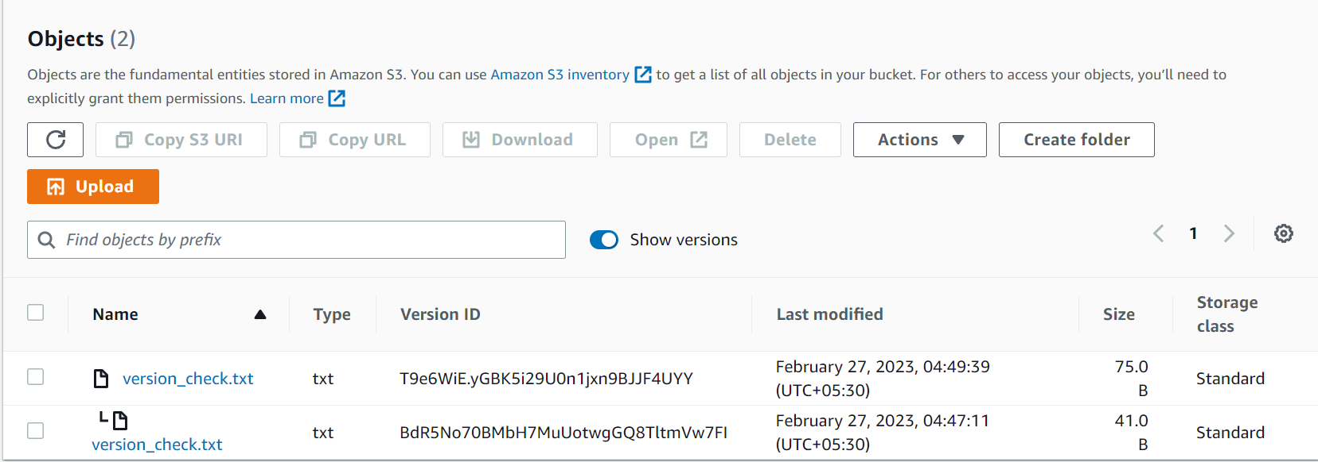

*Static Web Hosting:*

1. Click on bucket, add objects “index.html” and “error.html” click on properties, click on edit under the static web hosting.

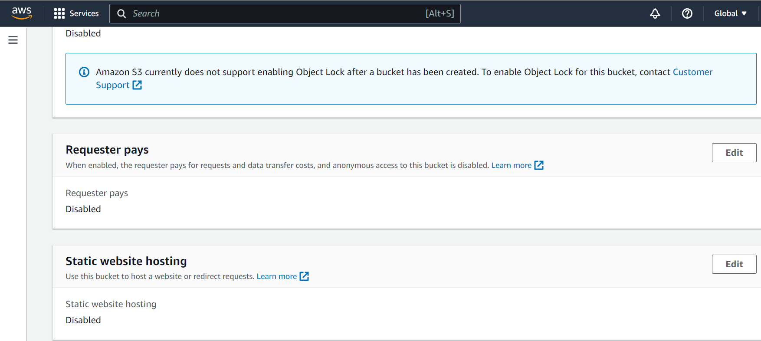

1. Enable the static web hosting and fill all the blocks.

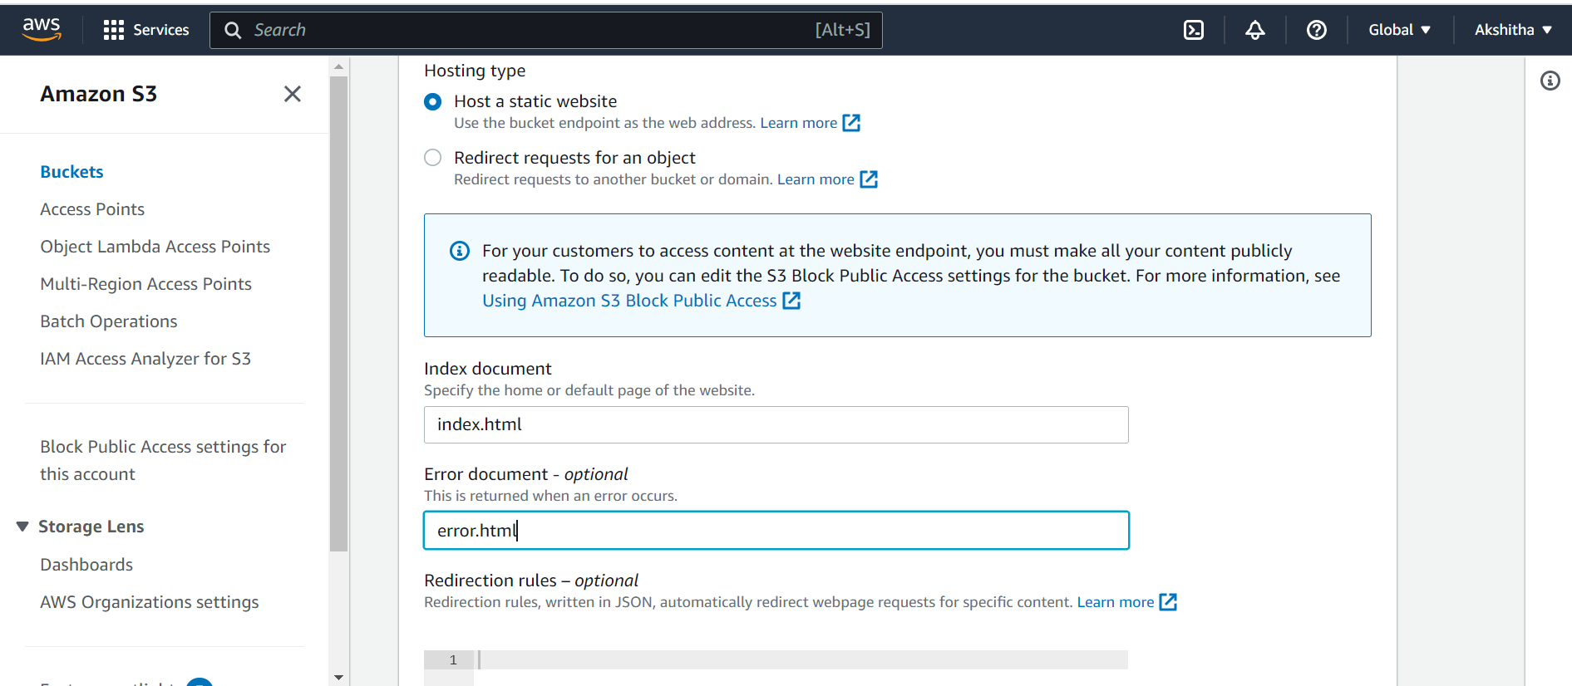

1. Copy the website end point and paste in the browser.

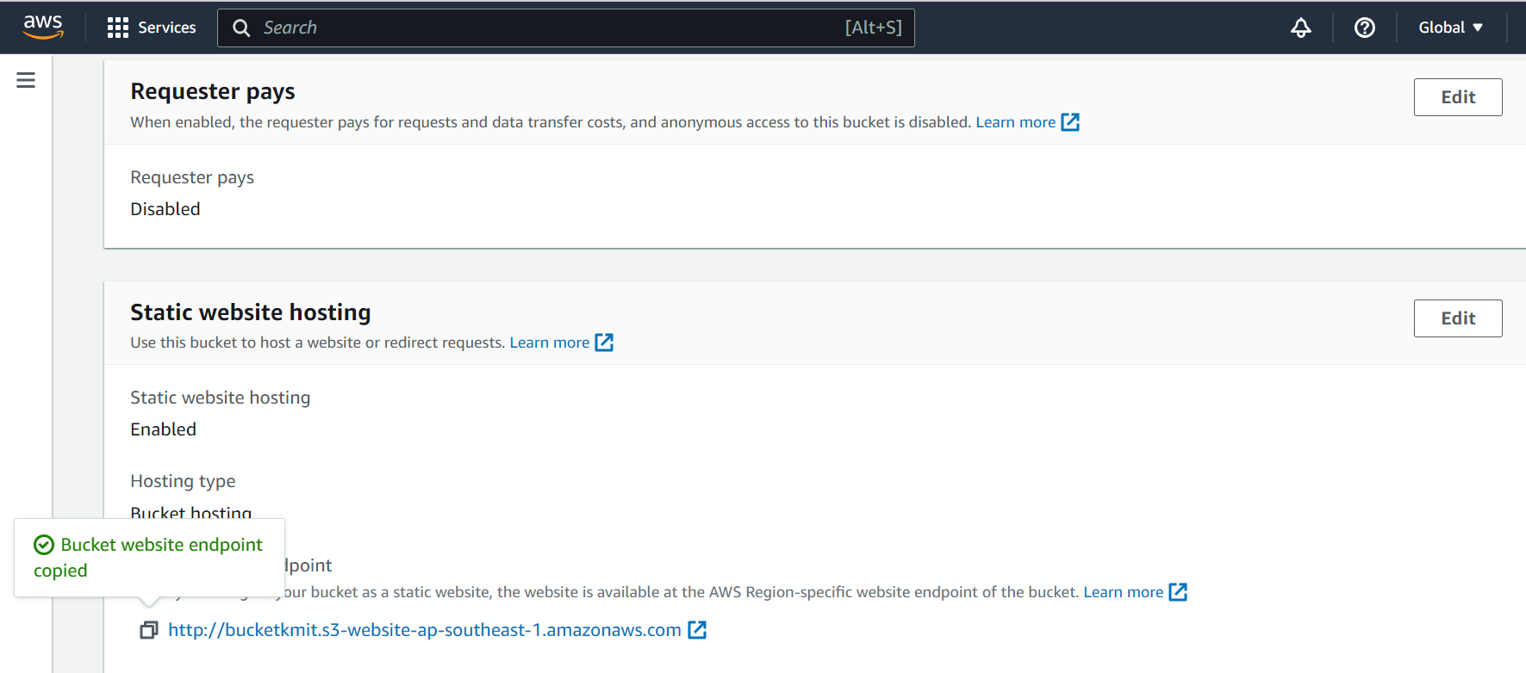

1. This is displayed.

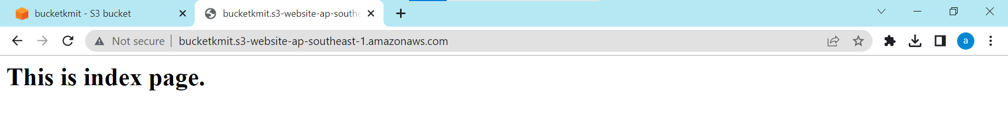

1. The error page is displayed, when there is problem with index page.

